# 

Property Tax Exemption Administration Procedures

Prepared for the Cook County Assessor’s Office

UIC Capstone Team

**Matt Amann • Carter Craig • Tim McMahon**



# Executive Summary

The Cook County Assessor’s Office (CCAO) is responsible for all residential property valuations, residential property tax levies, and residential property tax exemptions within Cook County, Illinois. There are eight residential property tax exemptions that the CCAO administers: Homeowner, Longtime Homeowner, Senior Citizen, Senior Freeze, Returning Veterans, Veterans with Disabilities, Persons with Disabilities, and Home Improvement. All eight contain different metrics for eligibility, and the application and renewal processes vary depending on exemption type. Responsibility for administration of exemptions is spread across multiple departments, resulting in a lack of comprehensive institutional knowledge of the process in its entirety.

In January 2020, the CCAO submitted a request for assistance in documenting, standardizing, and charting the residential exemption process to the University of Illinois at Chicago’s College of Urban Planning and Public Affairs Public Administration Capstone Program. By the end of January, the Capstone Team had been identified, met with the CCAO client lead – Chief Data Officer Rob Ross – and his team, and signed a Memorandum of Understanding to determine project scope, and timeline, and agreed upon the following deliverables:

1. Standard operating procedures governing the administration of residential exemptions.
2. Data dictionaries of all data tables supporting the administration of residential exemptions.
3. Inventory of scripts, queries, jobs, and other data operations supporting the administration of residential exemptions.
4. Gantt chart of the administration of residential exemptions.

The purpose of Deliverable A is to provide a comprehensive overview of the residential exemption administration process. To this end, the Capstone Team decided that this should be limited to ten steps or fewer to maximize understanding by and utility for all departments involved. Deliverables B and C provide the next layer of detail for CCAO users – from frontline workers to management – involved in the administration process. This includes data dictionaries and an inventory of the jobs, scripts and queries that are used to connect the paper-driven process of administration to the digital process of record-keeping and data storage. Deliverable D provides a timeline of departmental responsibilities, deadlines, and interdepartmental dependencies for the administration process within each annual cycle. This deliverable is also intended to be utilized agency-wide and was written to be easily understood by third parties and the public.

Both the Capstone Team and client agreed it would be most effective to begin the first phase of the project with interviews to attain the most relevant information to chart the residential exemption process. Interviews with nine individuals were conducted over the first three weeks of February; these individuals were representative of the departments deemed relevant to the residential exemption process by the client lead. In addition to their experience, many of them provided the Capstone Team with copies of files, documents and contemporaneous notes that are referenced during workflows. The results were organized and summarized in the form of an HTML document submitted to the CCAO for use as an internal reference manual, along with the source code to be maintained as an internal webpage.

Together, the deliverables address the CCAO’s relevant problem by providing organization, structure and an integrated reference manual to a byzantine process that is paper-driven and decentralized. The Capstone Team’s deliverables will lead to increased awareness and overall clarity of the residential exemption process which will assist in making the process more efficient for taxpayers of Cook County as the CCAO transitions to an updated system.

# Table of Contents

Executive Summary - 1 -

Table of Contents - 2 -

Acknowledgements - 3 -

Glossary of Relevant Terms & Acronyms - 4 -

Introduction - 6 -

The County Assessment Process - 6 -

Residential Exemptions: Issues and Process - 8 -

Development of Capstone Deliverables - 10 -

Literature Review - 13 -

Introduction - 13 -

International Association of Assessing Officers (IAAO) Audit - 13 -

Civic Consulting Alliance Report on Transparency - 15 -

The Use of Process Mapping in the Public Sector - 16 -

Conclusions - 17 -

Methods - 18 -

Interviews - 18 -

Process Mapping - 19 -

Data Mining and Organization - 19 -

Findings - 20 -

Interviews - 20 -

Process Mapping - 21 -

Data Mining and Organization - 22 -

Recommendations - 24 -

Conclusion - 25 -

References - 26 -

List of Appendices - 27 -

# 

# List of Figures and Maps

[Figure 1: CCAO Organizational Chart with Exemption Focus - 5 -](https://uic365-my.sharepoint.com/personal/mamann3_uic_edu/Documents/Final%20Report_Master.docx#_Toc37386141)

[Figure 2: Map of Cook County - 6 -](https://uic365-my.sharepoint.com/personal/mamann3_uic_edu/Documents/Final%20Report_Master.docx#_Toc37386142)

[Figure 3: Cook County Triennial Reassessment Process - 7 -](https://uic365-my.sharepoint.com/personal/mamann3_uic_edu/Documents/Final%20Report_Master.docx#_Toc37386143)

[Figure 4: CCAO Residential Exemption Breakdown by Department, Division, Unit - 9 -](https://uic365-my.sharepoint.com/personal/mamann3_uic_edu/Documents/Final%20Report_Master.docx#_Toc37386144)

[Figure 5: Snapshot of CCAO HTML Tool - 12 -](https://uic365-my.sharepoint.com/personal/mamann3_uic_edu/Documents/Final%20Report_Master.docx#_Toc37386145)

[Figure 6: Internal Process Map of Residential Exemption Process - 22 -](https://uic365-my.sharepoint.com/personal/mamann3_uic_edu/Documents/Final%20Report_Master.docx#_Toc37386146)

# Acknowledgements

The Capstone Team would like to acknowledge the many individuals who were helpful to this project often on top of their venerable and busy role as public servants.

To the leadership of the Cook County Assessor’s Office including Fritz Kaegi and the Deputy Assessors, especially Rob Ross, who have been excellent sponsors of this project. Their leadership and dedication to transparency will pay dividend to the people of Cook County for generations to come.

To the many staff members who made time for interviews including Jason Pyle, Justin Kirvan, Steve Pham, Lumni Likovski, Hazel Friaser, Nicole Jardine, Mirella Villafuerte, Mark Kos, and Martin Paulson. This process works because of the amounts of effort and sacrifice they make daily. Without their shared knowledge, expertise, and perspective this project would have been impossible.

To Ashley Tillman and the CCAO Human Resources staff who onboarded the capstone team. Thank you for your flexibility and accommodation.

To the employees in the data science department, the Capstone Team is grateful for your help and accommodation.

To the many many staff members who process countless exemptions on behalf of the taxpayers of Cook County. These individuals cannot be overlooked. Without them and their dedication to their work, the people of Cook County would be worse off.

To the team at The Exemption Project for their work on behalf of taxpayers and good government.

To the IAAO and CCA for the research and auditing they had already performed. Their publications were an excellent source of background knowledge for our project.

To the University of Illinois at Chicago College of Urban Planning and Public Affairs faculty and staff, especially Dr. Thompson who has been a helpful guide on this project,

The Capstone Team extends its sincere gratitude.

# Glossary of Relevant Terms & Acronyms

**Adlexx:** The vendor that handles the physical process of mailing notifications containing information about exemptions and eligibility to the appropriate addresses.

**AS400:** A “green screen” mainframe computer client system that was introduced in 1988.

**Assessed Value (AV):**  The assessed value of a property is typically just a percentage of the property’s actual value that limits the amount of taxable value.

**Civic Consulting Alliance (CCA):** A pro bono government consulting nonprofit based out of Chicago.

**Cook County Assessor’s Office (CCAO):** The sole authority responsible for all real property valuation within County borders; these values serve as the basis for the property tax revenue collected for the operation of the interior governmental districts.

**Cook County Board of Review (BOR):** Reviews the assessments of all property within Cook County to the extent authorized by the Property Tax Code, corrects all assessments which should be corrected, raises, lowers, and/or directs the Cook County Assessor to change, correct, alter, or modify assessments as justice may require.

**Data Dictionary:** A document which describes the format of data tables and records used in the administration process.

**Data Inventory:** Serves as a central repository for all of the code and language that make up the scripts, jobs, and queries that are executed on various computer systems in order to perform the tasks related to access, storage and manipulation of data related to residential exemptions.

**Equalized Assessed Value (EAV):** The assessed value is further altered by the application of an “equalizer” from the state to produce an Equalized Assessed Value (EAV), which is meant to provide interjurisdictional equity of taxation from county to county.

**Gitlab:** A web platform used by coders and developers to collaborate on projects, maintain version control, and host production software.

**Homestead Update Display (HUPD):** An interface that puts residential exemption applications batches into the TSR.

**Illinois Department of Revenue (IDOR):** Administers Illinois tax laws and collects tax revenues for taxpayers.

**International Association of Assessment Officers (IAAO):** Offers education, technical standards, consulting services and many other resources to the property valuation and tax policy community.

**Legacy Systems:** This is a division within the CCAO that specializes in older computer systems such as the Taxpayer System of Record.

**Markdown:** A widely-used formatting language used to generate HTML code, the common programming language that runs unseen in web browsers to properly display most websites.

**Master File (MF):** This file is created at the beginning of the exemption process for any given year. It is created by making a copy of last year's file. All exemption related work is done on this file.

**Property Index Number (PIN):** The unique record locator for a real estate parcel.

**Taxpayer System of Record (TSR):**  The TSR is a computer system installed in the 1970s to manage information related to property taxes in a central database. It is used by the Assessor’s, Clerk’s, and Treasurer’s Office. It is widely referred to as “The Mainframe” by staff. It operates using a programming language named “cobol” which is common in mainframe computers, such as the Taxpayer System of Record, but is an increasingly rare proficiency among the workforce.

**Residential Exemption:** The Assessor’s Office administers property tax exemptions that may contribute to lowering the property tax bill for homeowners. The homeowner exemptions listed below reduce the equalized assessed value (EAV), or taxed value, of a home.

**Homeowner:** Provides property tax savings by reducing the equalized assessed value of an eligible property. Most homeowners are eligible for this exemption if they own and occupy the property. Once this exemption is applied, the Assessor’s Office auto-renews it for you each year.

**Home Improvement:** The exemption allows a property owner of single-family home, condominium, and apartments up to six units to increase the value of their property  up to $75,000 without an increase of its assessed value for up to four years. The exemption is automatically applied by the Assessor’s office upon receiving a building permit for improvement.

**Longtime Homeowner:** This exemption enables a property owner to receive an expanded Homeowner Exemption with no maximum exemption amount. To qualify there has to be a significant assessment increase to exceed the maximum amount set by the state legislature. Fewer than 2% of homeowners qualify for this exemption and applications will be mailed to those properties that qualify.

**Persons with Disabilities:** Provides savings by reducing the equalized assessed value of property by $2,000 annually. Applicants must meet specific criteria to qualify.

**Returning Veterans:** Veterans returning from active duty in armed conflict are eligible to receive a $5,000 reduction in the equalized assessed value of their property for each taxable year in which they return.

**Senior:** Provides property tax savings by reducing the equalized assessed value of an eligible residence by $8,000. A new law allows for automatic renewal for seniors who received the exemption last year, meaning an applicant only has to apply once. Newly qualified seniors must file initial applications in 2020.

**Senior Freeze:** This exemption freezes the equalized assessed value of a property, meaning it remains at a fixed amount. It is important to note that this exemption does not freeze the amount of a property tax bill. The amount owed may fluctuate due to the local tax rate set each year by the homeowner’s local taxing district. Applicants must meet the income qualification and meet the requirements of the Senior Exemption.

**Veterans with Disabilities:** Qualifying veterans with disabilities are eligible to receive a reduction in the equalized assessed value on their primary residence. Those with 30%-49% service-connected disabilities receive an annual $2,500 reduction in EAV, 50%-69% receive a reduction of $5,000, and 70% are completely exempt from paying property taxes.

**The Exemption Project:** A public interest-oriented quantitative analysis startup working with the CCAO on residential exemptions.

**Triennial Reassessment:** Cook County property is reassessed once every three years. The Assessor will send out a notice to each property owner which lists the prior assessment, the proposed assessment and the filing deadline.

**Tyler Technologies:** Offers public sector software solutions designed specifically for the unique needs of state and local government organizations and school districts.

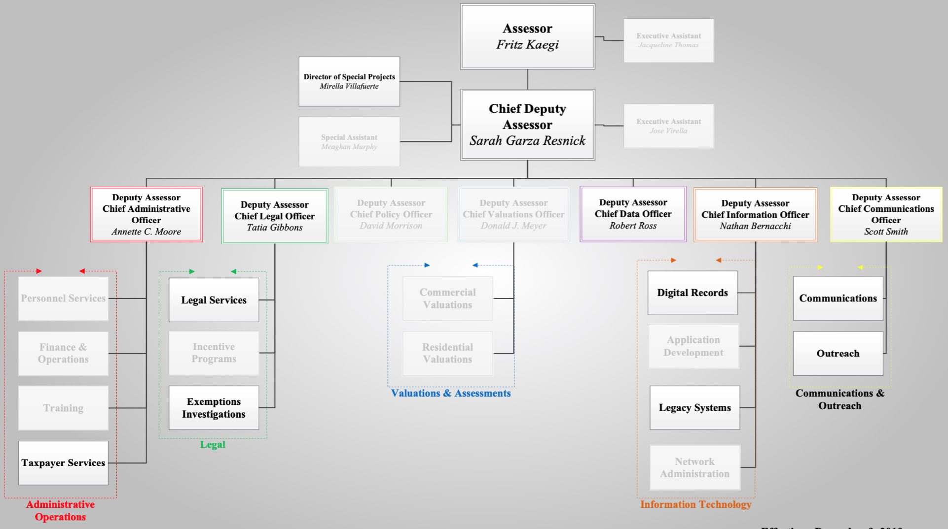

Figure 1: CCAO Organizational Chart with Exemption Focus

*Units related to exemption administration highlighted*

*Source: CCAO Internal Document*

# 

# Introduction

Figure 2: Map of Cook County

Home to over five million residents, Cook County is a mixed urban/suburban county in northeastern Illinois. While its largest city, Chicago, is home to the largest share of its people, Cook County contains 128 municipalities and a total of 800 units of government including parks and school districts among many other specific-mandate local governments.[1] In order to provide tax revenue for these 800 or so units of government, the Cook County Assessor’s Office assesses the value of over 4 Million parcels of property.

The Cook County Assessor’s Office is headed by an elected chief executive, the Counter Assessor. The incumbent Assessor, Fritz Kaegi, took office in early 2019. Under Kaegi are six Deputy Assessors and a Chief Deputy Assessor. The CCAO contains 7 departments, 15 divisions, and 16 units. Most of these groups and the employees who staff them work at the City/County Building in downtown Chicago. The CCAO also has three extension offices in the county. For an organizational chart the highlights the departments directly relevant to the Capstone Project, see Appendix B.

*Source: Cook County GIS Viewer*

## The County Assessment Process

Property taxes are the largest source of revenue for local governments in the United States. Cities, counties, townships, school districts, and many other units of government derive their revenue from a tax levied on real property within their jurisdictions. Unlike other types of taxes where fluctuations in the tax base are driven by changes in income or spending, changes in the tax base for a property tax are affected by changes in the assessed value of the property.

Assessment in Illinois and most other states is a county-level duty, and county assessors use a variety of methodologies to determine the value of a property. Often, an assessor will analyze market trends, ascribe values to certain constituent property features (such as a home’s master bedroom with an attached bathroom or a restaurant’s large, walk-in cooler), and record recent sales of similar properties in order to make this assessment. Cook County, with upwards of 1.2 million residential parcels, operates on a triennial reassessment cycle based on geography. The cycle, which determines much of the workflow of the office, is depicted in Figure 3.

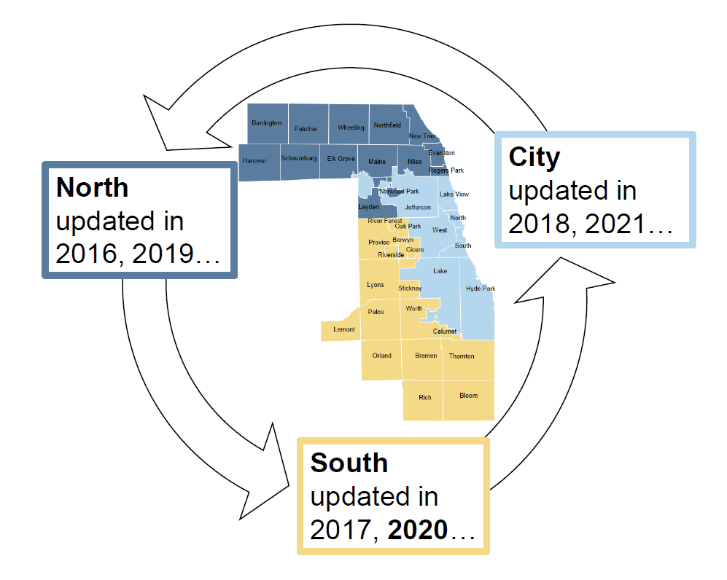While it varies by jurisdiction, it is typical to see a difference between the actual value of a property and its *assessed value*. The assessed value of a property is typically just a percentage of the property’s actual value that limits the amount of taxable value. The assessed value is further altered by the application of an “equalizer” from the state to produce an Equalized Assessed Value (EAV), which is meant to provide interjurisdictional equity of taxation from county to county.

Figure 3: Cook County Triennial Reassessment Process

Relevant to this report, the CCAO also administers exemptions of a certain dollar amount to a property’s EAV in compliance with Illinois Statute. In total there are nine exemptions available to homeowners, each of which is designed to reduce the tax incidence for certain groups of individuals such as veterans, seniors, and longtime homeowners. All exemptions are deducted from the EAV as the very last step before calculation of property taxes due.

*Source: CCAO Website*

In a separate process, the jurisdictions within a county determine their annual “levies,” which are the total revenue needed from the property tax. These levies are then multiplied by the ratio of individual property EAV to total jurisdictional EAV, generating the tax bill for the individual who is responsible for payment, usually the property owner. To illustrate, let us consider an example of a home owned by Jane Doe within a very small (hypothetical) jurisdiction, Townville, IL, which contains only one hundred property parcels.

The county assessor’s valuations department determines the market value of this parcel to be $500,000. Residential parcels are assessed at 10% of their market value, so the assessed value of Jane Doe’s home is $50,000. The state determines the equalizer rate for the county to be 1.25, which makes the EAV of Doe’s home $62,500. Doe qualifies for the Homeowner Exemption, which reducers her EAV by $10,000 to $52,500. The EAV of the other ninety-nine properties in Townville is $4 million, making the total jurisdictional EAV $4,052,500. This year, Townville determines its levy to be $275,000. Doe’s property tax due is determined as follows:

$$\frac{Doe's EAV}{Total Townville EAV} = Tax Rate × Levy = Property Tax Due$$

Substituting in the hypothetical values:

$$\frac{\$52,500}{\$4,052,500} = 1.295\% × \$275,000 = \$3,562.62$$

This process is repeated for all the jurisdictions in which Doe’s home sits, e.g. school districts, mosquito abatement district, water reclamation districts, etc. This aggregation is done by the county clerk so that the taxpayer is presented with one unified bill; but for our example, we consider that Doe resides in only one tax-levying district. Crucially, we can use the above equation in tandem with the un-exempt EAV to determine the approximate[2] value of the Homeowner Exemption Doe received:

$$\left(1 - \frac{un-exempt EAV}{exempt EAV}\right) × Property Tax Due = Savings$$

Or:

$$\left(1 - \frac{\$62,500}{\$52,500}\right) × \$3,562,62 = \$678.59$$

## Residential Exemptions: Issues and Process

When a taxpayer does not apply for an exemption for which they qualify, or miss the deadline to submit their application, they can apply for and receive what is called a “Certificate of Error” entitling them to payment in the amount owed from the jurisdictions to which they overpaid. The limitation on how far back they may claim these errors is determined by the date of the annual tax “scavenger” sale, but is about four years *ex post facto* at any given time. Governments must budget for these payments since the money has already been transferred to them as revenue, and in most cases already been appropriated as part of their levy. Many of our interviewees expressed concern and frustration about the effects these “C of E’s” on cash-strapped local governments, and bemoaned a “cottage industry” of tax professionals who mine public data in hopes of pocketing a percentage of the savings they remit to their clients.

Assessor Kaegi was elected in 2018 with the goal of bringing “operational changes, technological upgrades, and the elimination of favoritism” to the CCAO on the heels of an administration marred by scandal: a Chicago Tribune/Pro-Publica report released in late 2017 found that more expensive properties, which are typically owned by more wealthy individuals, were systematically under-assessed by the CCAO under the leadership of Cook County Democratic Party Chairman and former Assessor Joseph Berrios.[3] As a result, wealthy individuals were paying much less than their fair share of property taxes, forcing poorer individuals to overpay. One of the winds of change brought in Rob Ross to serve as Chief Data Officer, a new role within the CCAO.

Ross has undertaken a number of projects aimed at increasing the fairness, transparency, and efficiency of the CCAO: reorganizing the administration of residential exemptions has long been a project of considerable importance to him among competing priorities in an understaffed agency. To operationalize additional capacity, Ross worked with graduate students from the University of Illinois at Chicago in order to gather, organize, and centralize information about the process of exemption administration. The project was conceived as a starting point in the process of building institutional capacity for modern, efficient workflows that utilize specialist contractors such as The Exemption Project, a public interest-oriented quantitative analysis startup. More efficient processes will allow the CCAO to be proactive instead of reactive in its administration of exemptions, yielding justice and equity for taxpayers and consistency and reliability for the jurisdiction’s dependent on property taxes as revenue streams.

Pieces of the exemption administration workflow are handled by five departments: Data Science & Modeling, Information Technology, Communications & Outreach, Legal, and Administrative Operation. Each of these departments has delineated subsidiary operational units (see Figure 4 & Appendix B) to complete the work during the application period. Typical of a stove-piped process in a long-running bureaucracy, no organized, high-level abstraction of the entire process has been complied; rather, the information relevant to each unit is kept siloed in these work groups.

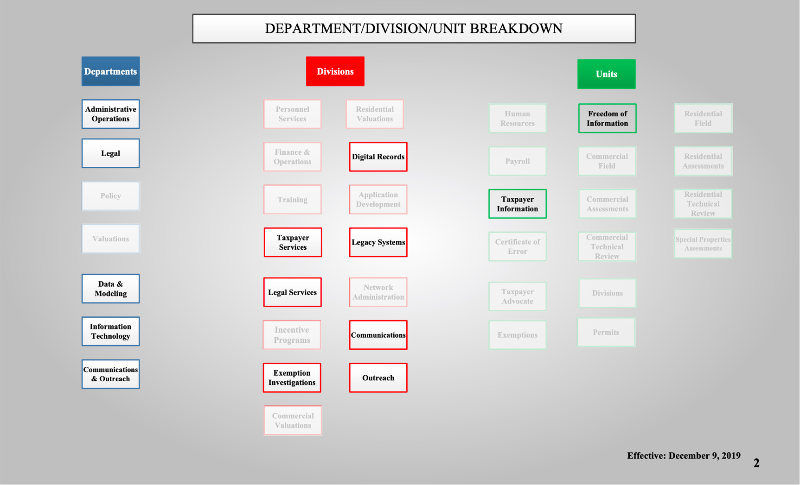The system, understaffed and driven at a relentless pace by the triennial cycle, is in near-constant motion: every department is scrambling to meet statutory deadlines, they are not always successful. This leaves little time to take stock of what the next department is working on, let alone strategically plan at an organizational level. In the absence of organization, exemptions continue to be administered at the behest of scrupulous taxpayers by frontline workers that have no time to consider their place in the process holistically, they must simply do as they have always done to meet the deadline. The work of the Capstone Team to collect information is valuable to begin the higher-level process of knowledge management that will open opportunities for strategic improvements in efficiency and subsequent organizational capacity.

Figure 4: CCAO Residential Exemption Breakdown by Department, Division, Unit

*Units related to exemption administration highlighted*

*Source: CCAO Internal Document*

Presently, the CCAO does not maintain any Standard Operating Procedures to describe, manage or regulate the administration of residential exemptions at any point in the process, let alone from beginning to end. The series of procedures is evocative of a game of telephone or a bucket brigade, where each link in the chain does their best to move information down the line, focused solely on the rote process of moving A to B. Subsequently, the public-facing application file (See Appendix G) is often the only guidance available to frontline staff and serves as their instruction manual to determine whether a taxpayer is eligible for an exemption.

Additionally, the technical tasks involved in the storage and management of data related to current and previous years’ exemptions are known only a few individuals with experience interfacing with the mainframe, which is considered the Taxpayer System of Record. This small cadre of specialists have a good understanding of the tasks, jobs and queries that need to be executed at various stages during the administrative cycle, however, attrition continues to shrink this group at a pace that has threatened the ability of the CCAO to continue normal operations. Most of these technical workflows remain a mystery to those not directly involved in them, and prior to the start of the Capstone project, the only extant documentation those involved could point to as a reference is a script file in Excel format that is inscrutable to even the organization’s data scientists. For a sample of this script, which has been disambiguated elsewhere in this report and the final client deliverable, see Appendix J.

## Development of Capstone Deliverables

To address these issues, the client requested deliverables of two types: high level abstracts meant for consumption and reference by management, executives and the public, and detailed reference materials that would assist frontline staff on day-to-day administrative operations. These items are also intended to be used in the integration of third-party contractors and software vendors that are increasingly relied upon in modern public administration. To address the former, the client initially requested a set of standard operating procedures for the administration of residential exemptions and a Gantt chart to describe the scheduled timeline and relationship dependencies of the steps in the process. These formats were decided upon by the client as the best way to facilitate interdepartmental understanding and to promote communication and transparency.

To address the latter, the client asked that information and workflows related to data processing and storage be collected, organized, and explained in a way that would make it easier to add to the group of specialists with the capability of interfacing with the mainframe. This would take the form of a “data dictionary” and a “data inventory.” The data dictionary is a document which describes the format of data tables and records used in the administration process. The data inventory serves as a central repository for all of the code and language that make up the scripts, jobs, and queries that are executed on various computer systems in order to perform the tasks related to access, storage and manipulation of data related to residential exemptions.

During the interviewing and data-gathering phases, the Capstone Team utilized agile project management processes and maintained an open line of communication with Rob Ross, the client lead for the project. In the course of weekly meetings, the team became more familiar with the client’s intended use for the deliverables and proposed a single deliverable format that would integrate all the aspects originally detailed in the memorandum of understanding in a user-friendly and scalable dynamic design. In consultation with the client and after presenting several mockup iterations that yielded extensive and useful feedback, the Capstone Team organized all deliverables into a single HTML file written in the accessible Markdown language.

Markdown is a widely-used formatting language used to generate HTML code, the common programming language that runs unseen in web browsers to properly display most websites; see Appendix K for more information on syntax and use. The HTML file runs on any internet browser and can be hosted on the CCAO’s own internal servers for use by all users on its local network. This format integrates the ability to nest information, media, external websites, and files in a single display, allowing the user to view the highest-level abstract information immediately and use an intuitive point-and-click interface to expand and collapse those processes which he or she would like to understand in greater detail. Expanding the detail level of the sections reveals reference information relevant to frontline practitioners, such as the programming scripts and queries to initialize a new year’s exemption process, or the qualifications and verification requirements for a particular exemption. This format will be easy if not completely intuitive to use for even the least technically-inclined among the staff, which is an important feature of any new tools deployed at the CCAO due to strict regulations regarding training imposed by civil service protections. It contains neither too much information nor too little; the desired amount of detail and granularity required is only a few clicks away.

Most importantly for scalability, all staff within the Data Science Department are familiar with Markdown and HTML syntax and can maintain the document as one would any web page. Within the broader Open Government movement of which Rob Ross and his team are proponents, the elimination of static files that are not machine-readable is of prime concern. The old bureaucratic trope about reports which gather dust on shelf has turned into PDFs which are untouched on a hard drive or become obsolete when processes change even minutely. Given the level of detail involved in the project, allowing for fluid updates of the content to reflect process changes and user needs yields a much more useful and adaptable tool than a snapshot at a certain point in time. Because the document is never truly “finished,” the Capstone Team was able to deploy (at the request of the client) the first version of the tool via the CCAO’s GitLab repository[4] in late March; by early April it has already been utilized by management within the CCAO and principals at the external vendor The Exemption Project.



Figure 5: Snapshot of CCAO HTML Tool

*Clicking within the highlighted area expands and contracts details*

*Source: Capstone Capstone Team HTML Tool*

# Literature Review

## Introduction

In August 2016, Bill Brantley wrote an article for the American Society for Public Administration’s *PA Times* titled “Now is the Time to Reinvent Legacy Government Processes*.*” Brantley told the story of a colleague that worked at the Department of Energy in the 1970s while the agency was attempting to streamline standards for energy efficient buildings. His colleague took a very complicated process and mapped it out for his boss:

When the boss came into the meeting room, my colleague had the newsprint taped to the wall. Actually, the newsprint covered all four walls as it circled the meeting room. The boss, having immediately seen the problem, worked with my colleague to streamline the procurement process down to 15 steps while still maintaining the accountability and fairness of the procurement process.[5]

Mapping out the process and boiling it down to 15 steps showed the changes that needed to be made within the department’s legacy IT systems and procurement processes. This is similar to the challenge that was posed to the CCAO Capstone Capstone Team. Using reports from the International Association of Assessment Officers, the Civic Consulting Alliance, and academic journals, the Capstone Team was able to highlight both the organizational issues facing the CCAO and determined the solution of crafting process maps as a foundational element to guide change over time.

## International Association of Assessing Officers (IAAO) Audit

In May 2019, the International Association of Assessing Officers (IAAO) conducted an audit or comprehensive review of operations of the Cook County Assessor’s Office at the request of the new Assessor, Fritz Kaegi. The conclusion of that audit stated:

It is the conclusion of the IAAO Consulting Team that Assessor Kaegi’s administration inherited an environment that does not meet IAAO Technical Standards in the areas having a direct impact on valuation. This report describes the current condition of the Office’s operations and offers suggestions on how to address inequity in the assessment process for Cook County. It also offers a practical pathway to modernization through a set of recommendations based on IAAO standards and best practices.[6]

While this Capstone project is focused on the exemption process, adherence to the overall theme of modernizing the Assessor’s office is evident. In the audit, the IAAO found that the then-current process of valuation was focused on “assessment by appeals” with little to no investment targeted at advancing the proactive valuation procedures. The report attributes “outdated digital infrastructure” as a major issue when trying to improve internal processes and identifies four critical areas for needed improvement, three of which impact this project: staffing and skill development, adapting technology, and data quality.[7]

In addition to insufficient staffing levels, the audit highlights that prior administrations had not promoted training, educational or professional development within the organization. This has led to a “continual loss of institutional professional knowledge.”[8] At the time of the audit, the office was also having issues with the underlying data about the property characteristics used in mass-appraisal regression equations. With specific regard to data concerning residential properties, staff suggested to the IAAO investigators that that information may have been “originally compiled many decades ago through a survey mailed to property owners.”[9] The audit is explicit in its determination that the CCAO does not maintain data standards that are current and fit best practices for maintenance and accuracy within the assessment industry.

One of the main resources perennially lacking investment has been the technology depended upon by frontline staff to do their job. Specifically, the audit mentions the continued use of the legacy system, AS400, which is a “green screen” mainframe computer client system that was introduced in 1988. As the audit explicitly states, “The limitations and inflexibility of this system form a strong impediment to developing operational efficiencies; the system is a roadblock to improvements. Relying on dated software severely limits office modernization.”[10]

When the CCAO releases data to the public, which they have often done since Kaegi took office, they also provide a disclaimer on the AS400 system. Two disclaimers noted are the inability to use delimiters (characters that separate fields in a table, often commas or the | symbol) and limitation of information storage to a single field. According to the CCAO, without delimiters to separate fields in a category, it “has [been] impossible to determine algorithmically whether a 12 is a 1 & 2, or a 12, rending this field mostly useless for modeling purposes.”[11] Additionally, the limitation to a single input field has made it difficult to provide specificity on a property’s additional characteristics that may improve model outcomes. For example, the AGE field: in the AS400 system, AGE may only be used to capture a single time-related characteristic within a complicated property: “this field is mixed-use, sometimes capturing original structure age, someone capturing effective age, or age from the most recent major renovation.”[12] This is the reason that the shift to a more modern system was recommended by the IAAO.

The final recommendations within the audit incorporated the impending shift to a new wraparound assessment software system constructed by Tyler Technologies, as well as a call for increased staffing levels across multiple processes, and the need for more accurate data such as sales transaction data to improve valuation methods. While the findings and recommendations of the general audit are not be directly related to the process of administering residential exemptions, they provided the Capstone Team with useful background information about the state of internal operations of the CCAO. As the client organization’s goals for the use of the Capstone Team’s deliverables is to build an institutional understanding of a byzantine and confusing process, the Capstone Team considered it essential that they understand how the process fits into the organization’s strategic issues. Indeed, the process of administering residential exemptions encounters manifestations of all the issues mentioned within this audit: capacity, outdated technology, and the desperate need for clear and reliable data.

## Civic Consulting Alliance Report on Transparency

In May 2019, the Civic Consulting Alliance (CCA), a pro bono government consulting nonprofit based out of Chicago, released a report titled, “Residential Property Assessment in Cook County: Assessment Transparency.” Within the executive summary of the report, CCA mirrors the tone of the IAAO report as well as the client request for this project in stating that the CCA “emphasizes that bringing the whole system into compliance with industry standards will require fundamental changes in modeling, review processes, and data collection, and a shift away from reliance on appeals.”[13] Shifting away from a reliance on appeals relies first and foremost on understanding the entire internal review process at the front-end. As outlined in the CCA report, the ultimate goal of establishing more transparent methods throughout the CCAO is to build public trust around a process that is responsible for over $13 billion in annual governmental revenue.

The report cites the IAAO’s *Standard on Public Relations* in underscoring the importance of public access to the work that an Assessor’s office does: “personnel must understand policies and statutes pertaining to open records, public disclosure, and confidentiality, including an awareness of compliance timelines.”[14] Having CCAO staff understand every layer of their role within the assessment and exemption process is crucial to building trust in the organization. The report cites another IAAO *Standard on Mass Appraisal of Real Property* in highlighting the many benefits that manuals or reports can have internally and externally: “The manuals serve as a resource for current staff and can be helpful in training new staff or explaining the valuation process to other interested parties.”[15]

Documentation of process serves as a tool for transparency and should be meant for public consumption, in addition to its internal uses as a training tool and reference guide for staff and as a guidepost for future process improvements. An additional benefit of publishing manuals or process maps with the inclusion of statistical code and data models is the improvement of collaboration with other government entities such as the Board of Review (BOR), Treasurer, and Clerk’s Office, but also independent third parties for improvements or review.[16] Publishing these materials also makes them available to unaffiliated agencies for use in their own development of internal processes and procedures, which raises the caliber of governance across the country. The benefits of documenting processes within an assessor’s office (and indeed any public sector organization) are clear.

The CCA report concludes that it will take years and strenuous internal and external effort to improve the transparency of the CCAO. The CCA acknowledges that elected officials will have a major role to play if real transparency can take hold: “It will be up to the elected officials in the end-to-end assessment process to guide the planning and execution of the recommendations and improve the performance of the system.”[17] In the meantime, the CCAO has been working internally and through partners and consultants (like the Capstone Team), to allow the greatest number of people the ability to understand the process as it currently exists and their efforts to improve it in real time.

## The Use of Process Mapping in the Public Sector Mapping Public Value Processes

John Alford and Sophie Yates outline a framework for public value process mapping (PVPM) in the 2014 article published in *The International Journal of Public Sector Management*, “Mapping Public Value Processes.” The article states at the outset that visual representations of public sector processes are beneficial and necessary to understanding the system. They are important because people have an easier time understanding visual representations than textual:

Visualisations can make use of the human affinity for pattern finding (Ware, 2004); and draw on both the visual and the spatial working memory system (Logie, 1995). Scaife and Rogers (1996) also argue that visualisations can enhance our processing ability because users can abstract information ‘at a glance’, i.e. much more quickly than from an informationally equivalent textual description. During problem-solving, visualisations can therefore help reduce ‘cognitive load’, and assist an individual’s capacity for coping with complex task requirements (Cox and Brna, 1995).[18]

Alford and Yates argue that process mapping is an effective tool for providing the current state of play of a process. The method reveals the players or departments involved, the tasks they perform, and how the entire sequence of activities is connected to show the entire process.[19] Similar to the IAAO and CCA reports, the article explains how this can be a tool for incorporating the citizenry into a process that they may or should want ownership over. As the article states, “there can be public value in facilitating the conditions for deliberation about these collective purposes, such as constitutional arrangements, deliberative mechanisms or educational processes.”[20] Having the public involved in the system will continue to build trust in the system and will eventually lead to process improvements over time, but this can only happen if the system is understandable and transparent.

A potential benefit of process mapping over the long term is “unearthing unexpected actors,” which, according to the authors, allows “the public value map … to identify the ‘real’ culprits behind negative outcomes.”[21] To be clear, in the case of public sector processes the label of “culprit” is not mean to imply any insidious behavior, but it can be revealing to an organization that is trying to improve its processes. By laying out an entire process, the areas that work well and make sense are revealed as easily as the areas that may need improvement or additional clarity.

The final conclusion within Alford’s article is that the advantage of process mapping lies in the holistic nature of the approach. Process mapping “facilitates the identification and comprehension of a broader range of causal factors and actors, which heightens the possibility of imagining new and innovative solutions to difficult public policy issues, and alternative ways of delivering public services.”[22] The IAAO audit, CCA report, and the CCAO have all expressed support for innovative change over time in how the CCAO delivers its services. Process mapping is a helpful tool internally to lay another piece of the foundation for this change.

### Process Mapping: The Foundation for Effective Quality Improvement

Robert Marriot’s July 2018 article in *Current Problems in Pediatric and Adolescent Health Care* explained the importance and effectiveness of using a process map as the foundation for improvement in a complex system. While Marriot focuses on the healthcare system, he states that this process of mapping can and should be used for any complicated system. Marriot states, “The core premise of process mapping, regardless of the industry or setting, is that you cannot manage what you do not measure. By extension, it is difficult to determine what and how to measure if the steps, and the order they fall in, are not known.”[23] Marriot describes this as a visual representation of the who, what, when and where processes within an organization.

Marriot uses the example of the healthcare industry and patient wait times to show how process maps can be applied and why they can be helpful. Marriot’s process of mapping and listing the duration between steps in the organizational process provided additional data that would not have been available otherwise. Through Marriot’s example, it is clear that process maps can be a method for making new data available that would otherwise be unavailable, such as wait times within an internal process.

Process mapping also tends to take the view of the respondent. So the more people, departments or organizations that are included in a process, the more comprehensive that the process will become.[24] This is especially important in the CCAO case where interviewing the appropriate respondents and combining their perspectives can provide a more comprehensive view of the exemptions process above the silos of a person or department's individual steps within the entire process.

Marriot’s conclusion is that process maps should be incorporated as a “foundational element” to any change within a complex system. It can and should be used to measure or map steps within a process that spans departments or semi-autonomous units. It can be used to measure inputs and outputs within an entire organization. By mapping all of these factors and more, the process map can be used to gain insight or data into an internal process that would otherwise go unmeasured. By measuring and mapping the process, an organization can make process improvements.

## Conclusions

The IAAO and CCA reports stressed the necessity of fundamental change if the CCAO is to improve its processes and build public trust. Both point to increased transparency, both internally and externally, as the primary method for building that trust. The literature on organizational change indicates that the foundations of solid, long-lasting improvements are laid visually through mapping and subsequent analysis. Process maps themselves have additionally been shown to improve the understanding by internal and external audiences of complex processes. It also allows for the measuring of inputs and outputs within a system, on which to make process improvements. Building on the external reports and literature, the UIC Capstone Team has crafted process maps to show the state of play of the residential exemption process and a nested approach of information organization for CCAO users that can be used as a guide for both their day-to-day workflows and to gain an overall understanding of the process. These process maps and the reference tool will be used for strategic purposes and operational capacity building wherever the CCAO sees fit.

# Methods

## Interviews

The Capstone Team’s first task was to gather information from individuals of interest who were identified by the client lead, Rob Ross, as key stakeholders in the process of residential exemption administration. This was accomplished through a series of in-person interviews scheduled by an administrative assistant at the CCAO. These interviews followed a standardized format that was decided upon by the Capstone Team and formalized in an Interview Protocol prior to conducting the first interview (See Appendix C).

In initial development of the protocol, the Capstone Team relied heavily upon the presentation given by Shoham Geva and Kevin Nagura from the Civic Consulting Alliance on January 31, 2020. The CCA associates offered valuable behavioral insight about the subjects of interviews. For example, the Capstone Team was initially inclined to record the interviews in order to capture as much data from them as possible, but deferred to the experience of the practitioners who cautioned that any recording makes interviewees nervous and tus less inclined to share information. For practical advice on transcription and a review of the protocol in its early stages the team also consulted Dr. James Thompson, the MPA Capstone advisor, who has conducted extensive interviews with government officials in the course of his academic research. The protocol was also reviewed by Ross and periodically updated by the team to improve its efficacy.

Ten CCAO staff members were sought out for an interview. This list of individuals was drawn from every part of the organization which plays a role in the administration of residential exemptions. Despite the assistance of an internal scheduler, full access to workstations and support from Ross, scheduling the interviews was briefly a challenge for the Capstone Team and the deadline for interview completion had to be moved back one week. The effects of this delay had negligible impact on the overall timeline for deliverables, and the initial interviews were completed long before Governor Pritzker issued an Executive Order banning public gathering in response to the outbreak of COVID-19. It was initially considered possible that the Capstone Team would desire additional interviews to complete its information gathering beyond the initial phase, but due to the biological hazard, have adjusted to the exclusive use of electronic means of communication.

After these interviews were completed, the Capstone Team met for a long in-person session to discuss and organize the information gathered by the members of the group in order to decide the proper direction in which to proceed. The Capstone Team found that there was a great deal of collected information which could be set aside due to its minimal relevance to the deliverables and the CCAO’s goals for them. The information, however, was not discarded, nor was it irrelevant to the team: in some cases, it was incorporated into the deliverables as supplementary information, in others, it was useful as background information for the project report. It was this process of information filtering and curation that led to the Capstone Team’s idea to format the deliverables in a way that mirrored their own recursive approach to understanding the information as outsiders: first, an overview of the higher-level procedural information followed by the inclusion of more minute details of the particular workflows associated with the exemption process.

## Process Mapping

After completing the interview phase of the data gathering process, the Capstone Team allocated a full day to an in-person process mapping session. The first step was to print every diagram that was given to the Capstone Team by the interviewees on large sheets of paper; this allowed the Team to literally “take a step back and take it all in.” Taking this literal step back was necessary because the approximately twenty-five tabloid-size sheets covered most of a wall in the conference room the team met in. In this way, the Team was utilizing what the process mapping literature refers to as humans’ inherent ability to spot visual patterns.

As predicted, the team was able to quickly spot several diagrams (about 40% of the total) that were slight modifications or cosmetic updates of another: effectively duplicates that were very difficult to compare on a computer monitor. After discarding these, the team found it much easier to arrange the remaining diagrams into three groups: those directly relevant to the administration of residential exemptions, those only tangentially relevant, and those not relevant at all. Discussions about the utility of including these tangentially-related diagrams were settled by the prescient warning of Dr. Thompson, the UIC Capstone sponsor, which advised us against veering outside of the scope of the Memorandum of Understanding at the risk of underdelivering on its contents.

The Capstone Team set aside all diagrams and charts that were not directly relevant to their mandate, and were left with a half-dozen pages of process maps, the CCAO Organization Chart, a large grid stipulating qualification and verification requirements for the residential exemptions, and the “papers that drive the process:”[25] the exemption applications themselves. These are reproduced in Appendices B, E and G. From here, the team set to work with colored markers, sticky notes and a whiteboard to identify further patterns within the relevant subset of processes. This visual analysis prompted discussions about the tangential and concurrent processes that laid the foundation for the scope of content and structure of both the deliverables and the final report.

## Data Mining and Organization

The results of the interview process yielded a substantial amount of original documents, including contemporaneous notes taken and reference materials used by actors in the process of administering residential exemptions. Completion of the process mapping session helped the Capstone Team understand the way all of these documents could be organized into a coherent flow, but also indicated points at which there were gaps in their understanding, especially regarding the details of updating the records systems on the varying systems and applications used by the CCAO staff. It was decided that team member Matt Amann would focus on filling in the gaps in this stream and building out the draft of the deliverable to the client, while team members Carter Craig and Tim McMahon would focus on consolidating the deliverable for the Capstone class.

Amann was a logical choice for this task, as his experience interning at the CCAO afforded him with familiarity with the structures of data storage within the organization and his educational focus on quantitative analysis provided him with the tools necessary to perform the complicated mining and organization processes necessary to deliver a coherent and user-friendly product. Even so, the task was far from simple, as it entailed a detailed manual search through the CCAO’s shared internal drive while on-site, followed by a laborious organization and reformatting of the notes, data, scripts and instructions he found. A three-stage iterative trimming process was decided upon to divide the work into manageable chunks, first determining files that would be “possibly relevant,” which were to be reduced to “likely relevant” and finally “directly relevant.” The directly relevant files were the only ones to be summarized or reproduced and organized into the final deliverable.

The initial search yielded several thousand files that were deemed possibly relevant to the process, which were rather easily culled with a second pass into several hundred which were likely relevant. Determining direct relevance was a much more difficult task, as it necessitated the introduction of a temporary file structure system while documents and spreadsheets spanning dozens of authors and three decades were compared and organized into the abstract framework decided upon during the process mapping session. After the the directly relevant files had been demarcated and organized into a local file system, the final task was to reformat them into an accessible framework that could be deployed across the client organization.

Amann utilized MacDown, a Markdown client for macOS that takes specifically-formatted plain text and generates HTML code that can be run on any browser on any operating system. Use of the Markdown formatting scheme allows users of any operating system who are familiar with its simple and widely-embraced conventions to easily make updates to webpages and other HTML-encoded files. The basic formatting conventions and an example of their use in the Capstone project are provided in Appendix K. HTML was selected as the format for the client deliverable because it is ideal for organizing information that is contained in multiple file formats. While modern web pages often utilize additional coding schemes on top of the HTML to add additional functionality, one can hardly imagine a website that does not include images, tables, links to external sites, and multiple formatting schemes: all of these are utilized in the HTML reference tool derived from this process.

# Findings

## Interviews

The Capstone Team initially used the interview method to inform the development of standard operating procedures, which then evolved into a process mapping tool based at the client organization’s request. The findings of the interview phase were primarily qualitative since the client and MOU did not call for quantitative findings. Specifically, the client was seeking findings on the exemption process and not overall exemption numbers. The general mood, which pervades the organization at all levels, that the residential exemption process is paper driven, takes incredible effort, is imprecise, overly complicated, and inputted into an outdated system. This was corroborated by the materials collected and interviews conducted by the Capstone Team. Any frustration with the process internally and externally is generally justified.

By and large, the residential exemption process is limited by the limitations of the Taxpayer System of Record. This computer system in its present form, is not only accessible only to staff knowledgeable in an obscure coding language, its data is particularly inflexible because it exists in a non-relational database. There is no way to interact with the computer system through a digital interface (i.e. a computer screen), instead there is a huge office space in the City/County Building dedicated to printing readouts. It only updates nightly, a feature that is baffling to office workers who are used to a Google Document that updates and saves after nearly every sentence they type.

## Process Mapping

The Capstone Team identified eight major steps in the process of residential exemption administration and applied the findings from the interviews to determine the departments, subunits, and technology involved in each step. The team utilized a free and open-source application, draw.io,[26] to present this information in a visually appealing and easily understandable manner; see Figure 6. While inclusion of the technological aspect would have made the diagram too crowded for easy digestion, this information is included in the top-level visualization of the HTML reference tool. draw.io was also used to highlight the portions of the CCCAO organizational chart containing the departments and subunits involved in the process, see Figures 1, 4 and Appendix B.

The team previewed these items to Rob Ross, the client lead at the CCAO, during one of their last in-person meetings at the beginning of March. He expressed immediate surprise at the breadth of organization-wide involvement in and the extent of interdepartmental coordination required for each of these discrete steps; his rapid comprehension of the implications of the visualization demonstrated to the Team that their analysis was headed in the right direction as they set about filling in the details involved in each subprocess. Capturing impressions like Ross’s are valuable feedback to a team buried deep in the weeds of a byzantine project, and a helpful feature of the agile management principles that governed our interactions with the client.

As the figure demonstrates, when consolidated into eight discrete steps, there is significant operational crossover between work groups in order to accomplish this process from beginning to end. This is indicative of the extent to which the process is comprised of many small pieces of several working groups and lacks central coordination. This diagram is meant to be consumed by users that are both familiar and unfamiliar with process of administration of residential exemptions; it is likely that the CCAO will make it available to the public as part of their ongoing efforts to promote transparency and build public trust. Within the eight steps, the team has nested several layers of details that are informed by the original internal process maps. This is best viewed consumed within the HTML tool, but much of its content is summarized in the following section and included in minute detail in Appendix H. The nested layers are meant to promote accessibility to a wide variety of stakeholders within and outside of the CCAO, allowing users to quickly choose the level of detail they need to participate in the process.

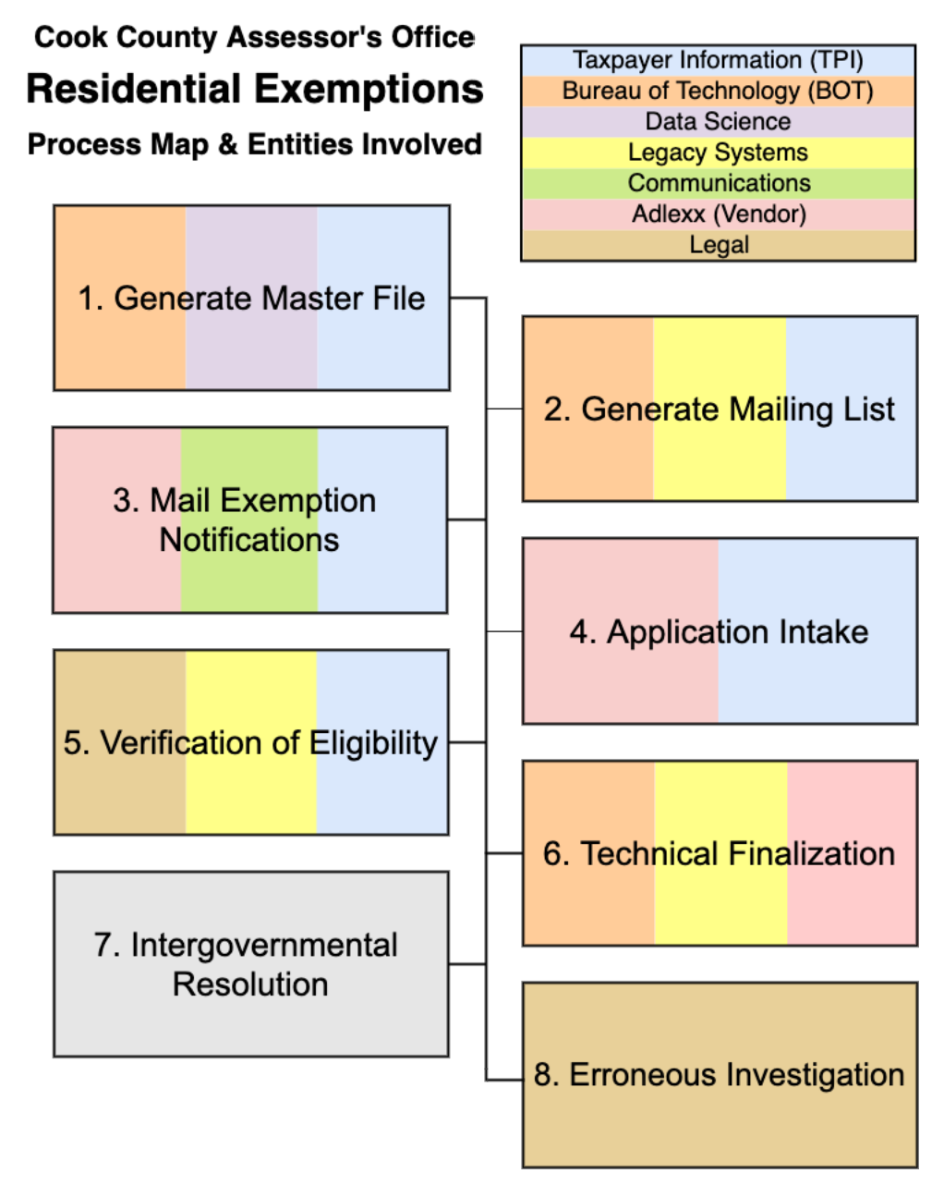

Figure 6: Internal Process Map of Residential Exemption Process

## Data Mining and Organization

Based on the methods used by the Capstone Team, the CCAO residential exemption process can be abstracted to eight steps. Additional levels of detail describing the steps summarized below can be found in Appendix H of this report, but it is strongly recommended that the consumer utilize the HTML tool which integrates media and dynamic filtration. Once made public, it may be accessed from the CCAO’s GitLab repository[27] or by request from any of the members of the Capstone Team.

### Step 1: The Master File is generated.

The Master File is made up of records on all Cook County parcels that have received exemptions and is used to record work on residential exemptions in a given tax year. Exemptions are applied to this file and it is used to calculate all property taxes. The file is created by making a copy of the previous year’s file from the Taxpayer System of Record; the scripts, queries and jobs associated with this task are executed by Legacy Systems and the Bureau of Technology. Data Science works with Taxpayer Information to flag the parcels which are likely to experience a change in eligibility from the previous tax year; this includes properties which have been sold and which were owned by individuals that are believed to be deceased.

### Step 2: The mailing list is generated.

Using the Master File, Taxpayer Information coordinates with Legacy Systems and the Bureau of Technology to create a mailing list of residential parcels that may be eligible for exemptions. The mailing list is comprised of several lists, one for each type of exemption administered by the county and is generated based on information about the parcels in the Property Tax System of Record. The mailing list is sent to Adlexx, the vendor that handles the physical process of mailing.

### Step 3: Exemption notifications are mailed.

Adlexx uses the mailing list from Taxpayer Information and designs from the Communications Department to send notifications containing information about exemptions and eligibility to the appropriate addresses. The content of these notifications has been updated for this most recent tax year and is tailored to likely characteristics of the recipient taxpayer. A detailed decision tree that delineates the potential results of this process is provided in Appendix G, alongside the relevant notification designs.

### Step 4: Applications are received for intake and processing.

The majority of applications and the supporting materials needed for their approval are sent to the mailing address for the vendor, who processes applications en masse. The vendor scans them and formats them as PDF files, and then sends them in batches to the Taxpayer Information Department along with a spreadsheet that contains the relevant information. Some individuals send the application materials to the CCAO office or come to the office in person to turn in their application. Two or three Taxpayer Information staff are required to work full-time simply opening the mail received by CCAO during peak application periods. Other staff members work receiving in-person applications and assisting taxpayers in filling out their forms in the office and on the phone. 2020 is the first year taxpayers are able to e-file for some exemptions.

### Step 5: The eligibility of applicants is verified.

If the application meets the statutory standards for acceptance, it is put into batches to be entered into the Taxpayer of System of Record via the HUPD interface. Legacy Systems uses the AS400 system to verify that information such as name, PIN, and date of birth are correct and that changes made to in the Taxpayer System of Record will be accurate to the best of their ability. Occasionally, the Legal Department is consulted on “edge cases” that are ambiguous or confusing, these cases are most often the result of the legal ownership of a parcel is placed in a trust. Legal also occasionally issues memorandums that clarify some of these cases when courts rule on statutory interpretation.

### Step 6: Records are finalized and the system is closed.

Legacy Systems coordinates with Taxpayer Information and the Bureau of Technology to ensure that all updates have been made before closing the system; no updates to the exemption rolls can be made in the following period. Legacy Systems runs a series of jobs to finalize the programming for permanent changes to be made in the Taxpayer System of Record and sends them to the BOT, which makes the changes available to other county agencies, most importantly the County Clerk. Information is printed directly from the Taxpayer System of Record and hand-checked by the BOT for discrepancies before being summarized and sent to the Illinois Department of Revenue for calculation of the statewide equalizer rate.

### Step 7: The CCAO and the Cook County Clerk’s Office resolve the final results.

Once an equalizer is determined, it is applied to all assessed values to determine their Equalized Assessed Value (EAV). Teams from the County Clerk and the CCAO meet to discuss the results of this calculation and make adjustments as necessary to ameliorate discrepancies between their records systems. At this point, the Bureau of Technology, Legacy Systems, and Taxpayer Information coordinate to reopen the system in order to make the adjustments determined necessary by the interdepartmental conference and add any late-arriving exemption applications to the records.

The system is then closed for the year and the exemptions are now deducted from the EAV by the Clerk, this final value is multiplied by the tax rate for each jurisdiction; the tax bills are then printed and mailed. If exemptions applications are received after the system is closed, Taxpayer Information automatically converts them to a Certificate of Error, which results in a higher initial tax bill that is offset by a refund issued at a later date.

### Step 8: Erroneous exemptions are investigated.

As required by statute, a subunit within the Legal Department investigates unqualified exemptions and uses a variety of means to recoup the revenues lost. Erroneously-granted exemptions result from both technical errors on the part of the CCAO and dishonesty on the part of the applicant, and often a combination of the two. This process is ongoing during all phases of the CCAO’s work cycle, but is included at the end of the of the administration process flow because it is necessarily retrospective.

# Recommendations

The client’s ultimate use for the centralized reference tool is to improve the efficiency of the process of administration of residential exemptions. To this end, the CCAO must consolidate as many processes as possible within a single department in order to continue to build upon the foundation of knowledge management that is laid by the deployment of the HTML reference tool. Certain departments like Data Science and Information Technology are designed to operate (at least in part) as providers of services to other departments, but taken as whole, it seems that every department involved in exemption administration operates as providers of service to the process: there is no central exemption authority that guides the process from beginning to end.

The HTML tool implemented by the UIC Capstone Team is intended to be a guide to assist in the understanding of the process holistically and can certainly be used as roadmap in planning any organizational changes, but these must be driven by strategic planning sessions that consider the long-term trajectory of the CCAO. Strategic planning is a time-intensive process, but hopefully the contributions of the Capstone Team have reduced the burden of the front-end legwork that is necessary to take the long view on building internal capacity. One notable omission from the final deliverable is input from the Bureau of Technology, which as a separate administrative body was not within the scope of the Memorandum of Understanding, but an investigation into the details of their involvement should be conducted if structural changes are to be undertaken.

The HTML tool is not “finished,” and should never be considered as such; it should be maintained as one would a piece of software by accommodating user feedback, adding features, and updating the interface as necessary. The Capstone Team has worked within the structures already in place at the CCAO in order to facilitate its rapid internal deployment and provided the Data Science department with the source code necessary to keep it up to date and relevant. To this end, it is recommended that the staff assigned to its maintenance develop a system that will organize requests for changes and improvements, which will likely need to operate outside of the structure of the GitLab repository to make it truly accessible to all interested parties.

This accessibility is imperative to meeting the transparency goals of the current administration and to efficiently leverage the specialized skills of outside vendors like The Exemption Project. Even the impending integration of Tyler Technologies’ new software can benefit from a centralized repository of information such as the HTML reference tool, provided the transition team is given access and their requests are accommodated into new versions in a timely fashion. It is the firm belief of the members of the Capstone Team that use of this tool in tandem with the recommendations set forth above will help the CCAO achieve its proximate goals of reducing the number of Certificates of Error and increasing the number of rightful exemptions granted; this will set the organization on the right path towards achievement of its long-term outcomes of increased public trust in the agency and a tax system that is fair and just for all the residents of Cook County.

# Conclusion

Property taxes are the backbone of municipal government in the United States and the same can be said about the many governmental units in Cook County. Therefore, the Cook County Assessor’s Office is an integral part of executing revenue raising and is charged with making taxpayers “pay their fair share” through accurate assessments of property value and the granting of due residential exemptions. These tax expenditures are meant to limit the tax incidence on certain groups. Through data collecting, the Capstone Team has centralized and effectively organized procedural information that was previously held in isolation within the far-flung cogs of the process. This information will give the CCAO the ability to communicate specifics about the process to decision makers looking to make improvements to the process.

# References

Alford, J., & Yates, S. (2014). Mapping public value processes. *The International Journal of Public Sector Management*, 27(4), 334-352. <<http://dx.doi.org.proxy.cc.uic.edu/10.1108/IJPSM-04-2013-0054>>.

Brantley, Bill. (August, 2016). *Now is the Time to Reinvent Legacy Government Processes*. <<https://patimes.org/time-reinvent-legacy-government-processes/>>.

Civic Consulting Alliance. (May, 2019). *Residential Property Assessment in Cook County: Assessment Transparency.* <<https://prodassets.cookcountyassessor.com/s3fs-public/reports/2018ResidentialPropertyTransparencyvf.pdf>>.

Cook County Assessor's Office. (February, 2020). *Cook County Assessor Model & Valuation Data Release.* <<https://datacatalog.cookcountyil.gov/stories/s/Cook-County-Assessor-Valuation-Data-Release/p2kt-hk36/>>.

Cook County Government. (Accessed April, 2020). *About Cook County*.

<<https://www.cookcountyil.gov/content/about-cook-county/>>.

Grotto, Jason and Kambhampati, Sandhya. (January, 2017). How we analyzed commercial and industrial property assessments. *Chicago Tribune.* <<https://apps.chicagotribune.com/news/watchdog/cook-county-property-tax-divide/methods-commercial.html>>.

International Association of Assessing Officers. (May, 2019). *Practices and Procedures Audit of the Cook County, Illinois Assessor’s Office.* <<https://prodassets.cookcountyassessor.com/s3fs-public/reports/PCS_Cook-County_Report_final.pdf>>.

International Association of Assessing Officers. (July, 2017). *Standard on Mass Appraisal of Real Property.* <<https://www.iaao.org/media/standards/StandardOnMassAppraisal.pdf>>.

International Association of Assessing Officers. (July, 2011). *Standard on*  
*Public Relations.* <<https://www.iaao.org/media/standards/StandardOnMassAppraisal.pdf>>.

Marriott, Robert. (July, 2018). Process Mapping – The Foundation for Effective Quality Improvement. *Current Problems in Pediatric and Adolescent Health Care*, Vol. 48 (Issue 7), 177-181. <<https://doi.org/10.1016/j.cppeds.2018.08.010>>.

# List of Appendices

1. Memorandum of Understanding
2. CCAO Organization Chart, Exemption Focus
3. Interview Protocol
4. Interview Summaries
   * Lumni Likovski, Director of Taxpayer Services
   * Nicole Jardine, Director of Communications
   * Justin Kirvan, Legal Department
   * Mark Kos, FOIA Department
   * Steve Pham, FOIA Department
   * Martin Paulson, Special Projects
   * Mirella Villafuente, Special Projects
5. CCAO Internal Process Maps
6. Gantt Chart: Schedule & Relationship Dependencies
7. Mailing List Decision Tree and Notification Designs
   * Senior Freeze (“Blue Booklet”)
   * Full Application (“Purple Packet”)
   * Senior Prime (“Gold Packet”)
   * Automatic Renewal Postcard
   * Long-Time Homeowner
   * Persons with Disabilities Renewal
   * Veterans with Disabilities Renewal
8. HTML Reference Tool Details
9. Data Dictionary and Inventory
10. Snippet of Sample Processing Scipt
11. Markdown Syntax and Use Example

Memorandum of Understanding

**Project Name:** Property Tax Exemption Administration Procedures

**Agency Contact and Contact Information:**

Rob Ross, Chief Data Officer

RRoss@cookcountyassessor.com

(773) 630-5210

**Primary Team Contact:**

Matt Amann

**Team Members and Preferred Contact Information:**

|  |  |  |
| --- | --- | --- |
| **Name** | **Phone Number** | **Email** |
| Matt Amann | (708) 703-2680 | mamann3@uic.edu |
| Carter Craig | (541) 971-0304 | ccraig5@uic.edu |
| Tim McMahon | (708) 214-8198 | tmcmah4@uic.edu |

Project Starting Date: **January 15, 2020**

Project Ending Date: **May 8, 2020**

**Description of Project and Objectives:**

The Cook County Assessor’s Office (CCAO) is the sole authority responsible for all real property valuation within County borders; these values serve as the basis for the property tax revenue collected for the operation of the interior governmental districts. The legal mandate of the office, handed down from the General Assembly of the State of Illinois, is to maintain uniformity in these valuations.

In accordance with 35 ILCS 200/15, the CCAO administers a number of exemptions for residential property owners and/or occupants. Some of these exemptions are automatically renewed under certain conditions, while others are not. There is an ad-hoc process by which erroneously-applied exemptions are removed before tax bills are created and mailed. There is a more formal function in the office to reclaim erroneous exemptions after they have been billed. The end-to-end process by which each exemption is administered is not well documented or understood by CCAO staff members.

The Kaegi Administration wants to document and standardize the administration of residential exemptions. The Administration would also like to become more proactive about, **A)** identifying erroneously applied exemptions *before* tax bills are mailed, and **B)** identifying each property that may be eligible for an exemption but is not receiving any. In order to accomplish these process improvements, the CCAO needs a set of standardized workflow documents and procedures describing the current state of the system of exemption administration.

**Scope of Work:**

This project will involve three Capstone Students from UIC (henceforth, the “Capstone Team”), the Chief Data Officer (CDO), and other CCAO staff as needed. The project will involve consulting with various CCAO staff members to understand and document the Information Technology (IT), including third-party interfaces (TPI), being used in the administration of residential exemptions, as well as intersecting legal procedures, and other workflows that intersect to administer residential exemptions. The purpose of gathering such information is for use:

* By the communications team to explain the process of obtaining or correcting an exemption.
* By the CDO to construct and deploy technology to support the administration of exemptions.
* By the Chief Deputy to monitor the administration of exemptions.
* By incoming administrations to understand how the office administers exemptions.

The Capstone Team is responsible for the following Deliverable Items:

1. A set of standard operating procedures governing the administration of residential exemptions.
2. Data dictionaries for all data tables supporting the administration of residential exemptions.
3. An inventory of scripts, queries, jobs, and other data operations supporting the administration of residential exemptions.
4. A Gantt chart of the administration of residential exemptions.

The CDO has provided a list of individuals in possession of crucial pieces of information regarding the current state of the system of exemption administration as follows:

**Consulted Individuals**

|  |  |
| --- | --- |
| *Name* | *Title* |
| Nicole Jardine | Director of Communication |
| Lumni Likovski | Director of Taxpayer Services |
| Justin Kirvan | Legal Counsel |
| Derrick Smith | Manager of Application Development |
| Mirella Villafuerte | Director of Special Projects |
| Hazel Frasier | Asst. Manager Taxpayer Information |
| Raul Moreno | Consultant |
| Jason Pyle | Dir. of Exemptions Investigation Unit |
| Mark Kos | Manager of Freedom of Information |
| Karen Drennen | Asst. Manager Records Management |
| TDB | Bureau of Technology Staff Representative |

The major action steps needed to successfully complete the project are as follows:

1. Deliverable: **Interview Protocol**

*The Capstone Team will develop a formalized interview protocol that will address structured outreach, scheduling, privacy, data sharing, and topics discussed in each interview.*

Date delivered: **1/29/2020**

2. Deliverable: **Inventory of data collected: notes, documents and other supporting materials.**

*The Capstone Team will conduct interviews with the persons comprising the above list of “Consulted Individuals” and any additional individuals with firsthand knowledge of the processes involved in the administration of residential exemptions. The team will consolidate and organize all qualitative information gathered during this process alongside “copies of convenience” of relevant source materials in order to facilitate production of the Deliverable Items. This will be done in a way that facilitates access to firsthand information by the client.*

Date delivered: **2/21/2020**

3. Deliverable: **First draft of Items A, B, C, D**

*The Capstone Team will distill the relevant information into the forms desired by the client. “Agile” project management practices will inform development of Deliverable Items to be of greatest utility to the client and the CCAO. A rough first draft of each item will be made available for comment by the client by the date below.*

Date delivered: **3/13/2020**

4. Deliverable: **Final draft of Items A, B, C, D**

*The Capstone Team will accommodate the comments received from the client in a final draft of the Deliverable Items to be submitted on or before the date below.*

Date delivered: **4/10/2020**

5. Deliverable: **PA 590** **Final Report (Draft)**

*The Capstone Team will provide the client a copy of the draft of the Final Report that will be delivered to Dr. James Thompson in fulfillment of course requirements.*

Date delivered: **4/10/2020**

6. Deliverable: **PA 590** **Final Report**

*The Capstone Team will provide the client a copy of the Final Report that will be delivered to Dr. James Thompson in fulfillment of course requirements.*

Date delivered: **4/24/2020**

7. Deliverable: **PA 590** **Project Presentation**

*The Capstone Team will present the findings of the previous months’ work to the client at the CCAO workplace during the first week of May.*

Date delivered: **5/4-8/2020**

Client Responsibilities:

* The client will facilitate meetings between Capstone Team and identified “Consulted Individuals” to be completed by 2/14/20. The Team will be responsible for scheduling all meetings, but it is the client’s responsibility to ensure follow-through by CCAO employees on these arrangements.
  + The client will be ultimately responsible for facilitating and/or expediting access to all information deemed relevant to Items B and C. This includes an expected 24-hour turnaround time on requests for source materials/data.
* All requests should be accommodated by
  + 2/17/20.
* The client will provide timely feedback on drafts, returning documents with comments within one week of turnover unless alternative arrangements are made at the time.
  + Deadline for comments on drafts of Items A through D: 3/20/20
  + Deadline for comments on draft of Final project report: 4/17/20
* Ensure access to database systems and shared virtual storage for purposes of information gathering and sharing.

Not within the scope of work:

* The Capstone Team will not develop any new policies.
* The Capstone Team will not develop a formal set of recommendations for improving the process of administration of residential exemptions.
* The Capstone Team will not be examining or collecting information which does not relate to the Residential Exemption process.
* The Capstone Team will not produce publication-ready materials in Items A through D. The Team *will* produce high-quality and visually attractive deliverables, but should not be expected to adhere to any agency “house style” or standards of official government communication.

Communication with Client:

* Biweekly status reports will be submitted by the Capstone Team, in accordance with “agile” project management principles.
  + At least one of these meetings will be in person, to the extent possible.
* Access to relevant CCAO Slack channel(s)

**Disclaimer:** This document and the research that supports it were undertaken by Master of Public Administration (MPA) students of the Department of Public Administration at the University of Illinois at Chicago (UIC) as part of their capstone course project. This work was conducted over a 16-week period between January 13, 2020 and May 8, 2020. The primary client of the research was the Cook County’s Assessor’s Office (CCAO). The findings and recommendations contained within the document represent the outcomes and opinions of the students engaged on the project and do not represent the opinions of UIC or the CCAO. The content of this document is intended for the use of the CCAO and cannot be distributed without their expressed consent.

The data contained in this report has not been independently verified. The students and faculty supervisor of the project believe that reasonable efforts have been made to ensure the accuracy of the document. It is intended for discussion purposes only and is provided without warranty. The Department of Public Administration disclaims any responsibility to update any information, including any new organizational, procedural or technological developments. The information is not intended to and does not constitute legal, financial, or other professional advice.

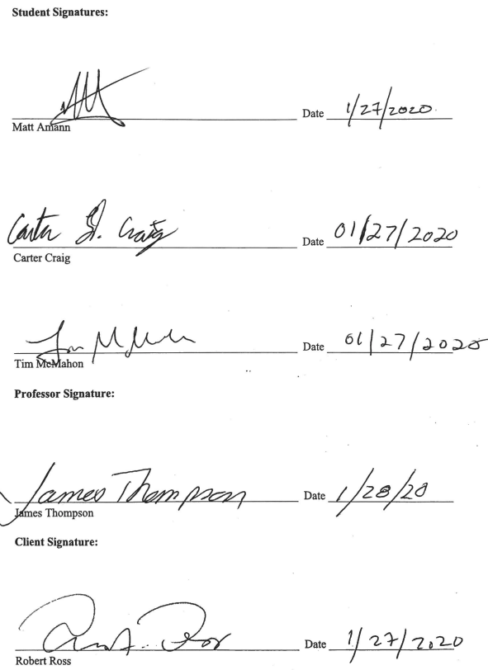

CCAO Organization Chart, Exemption Focus

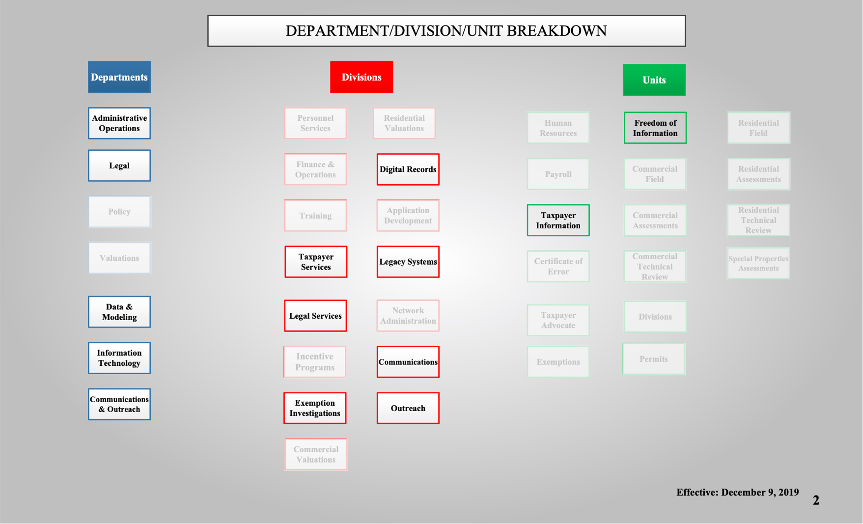

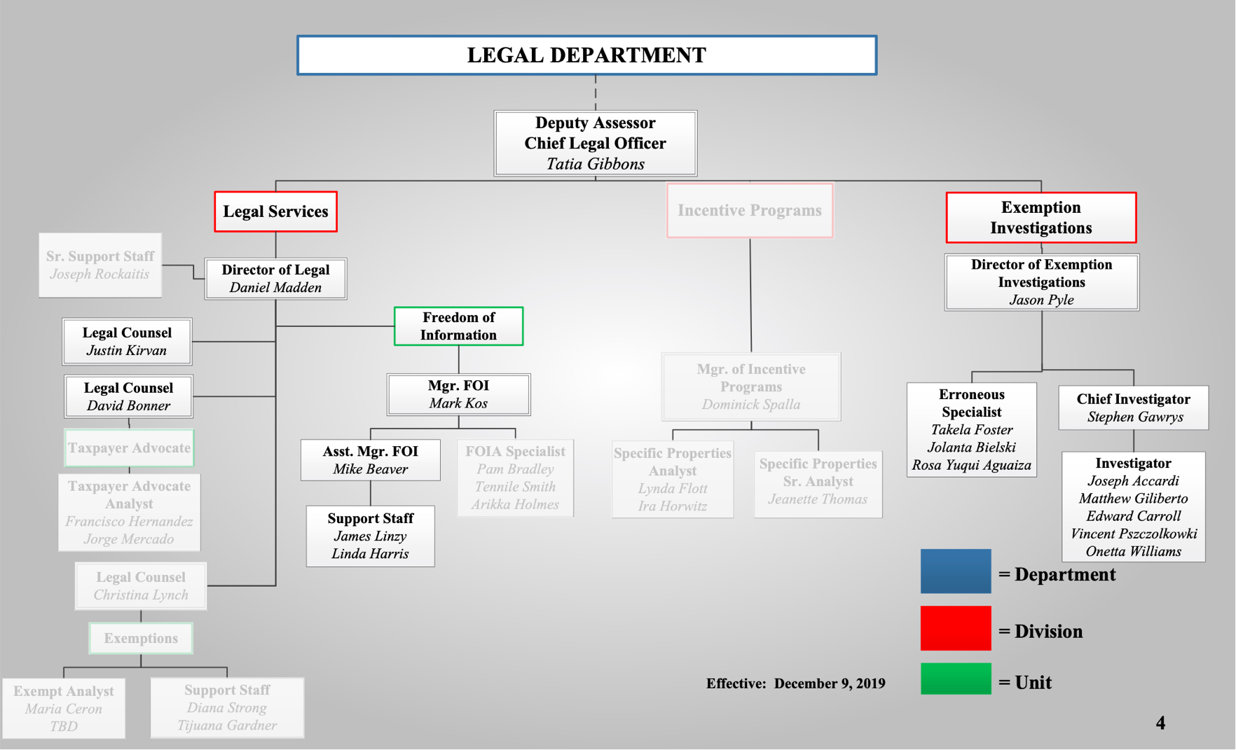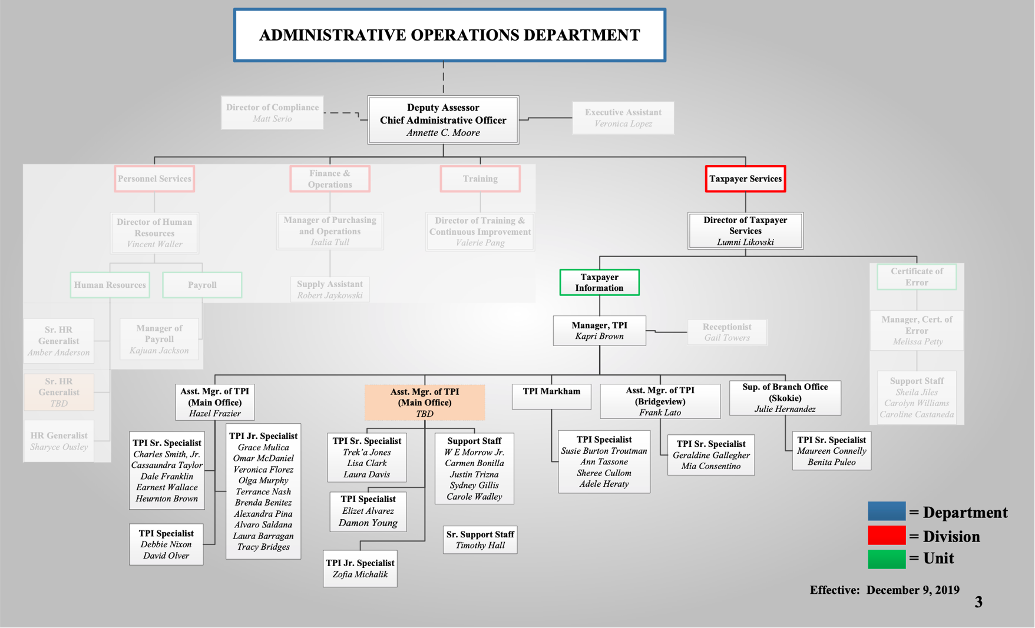

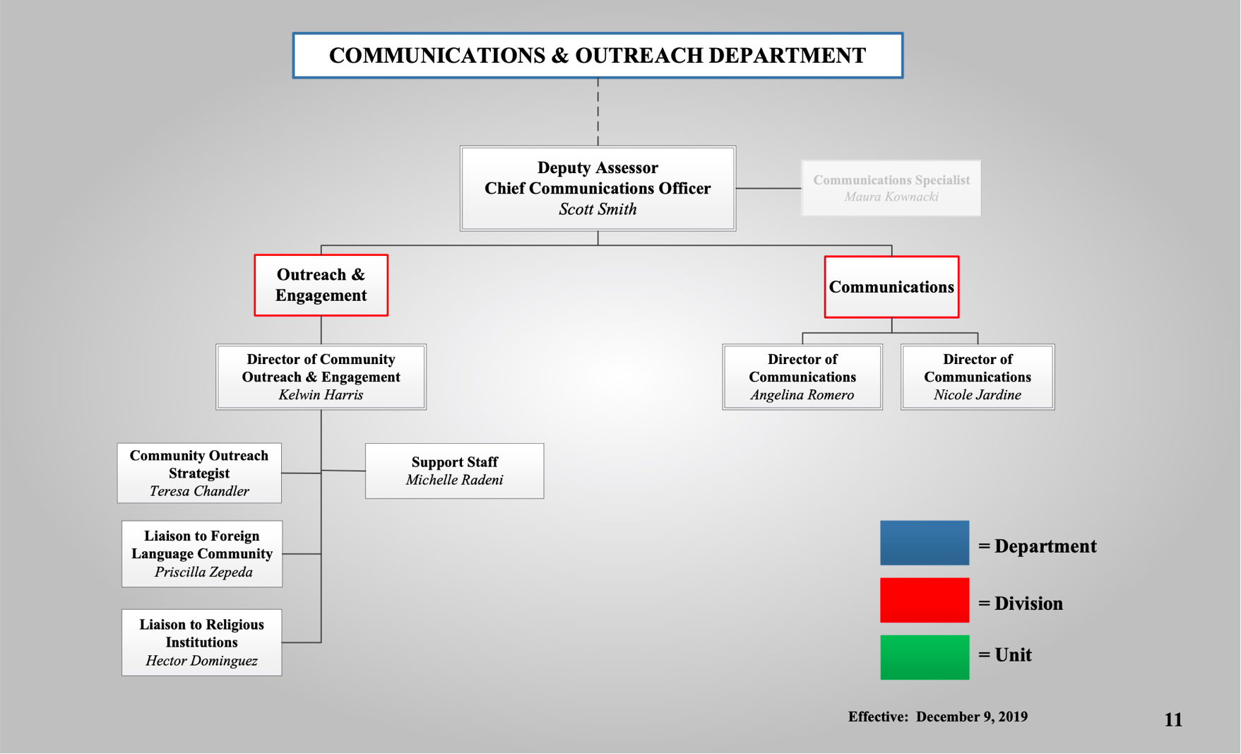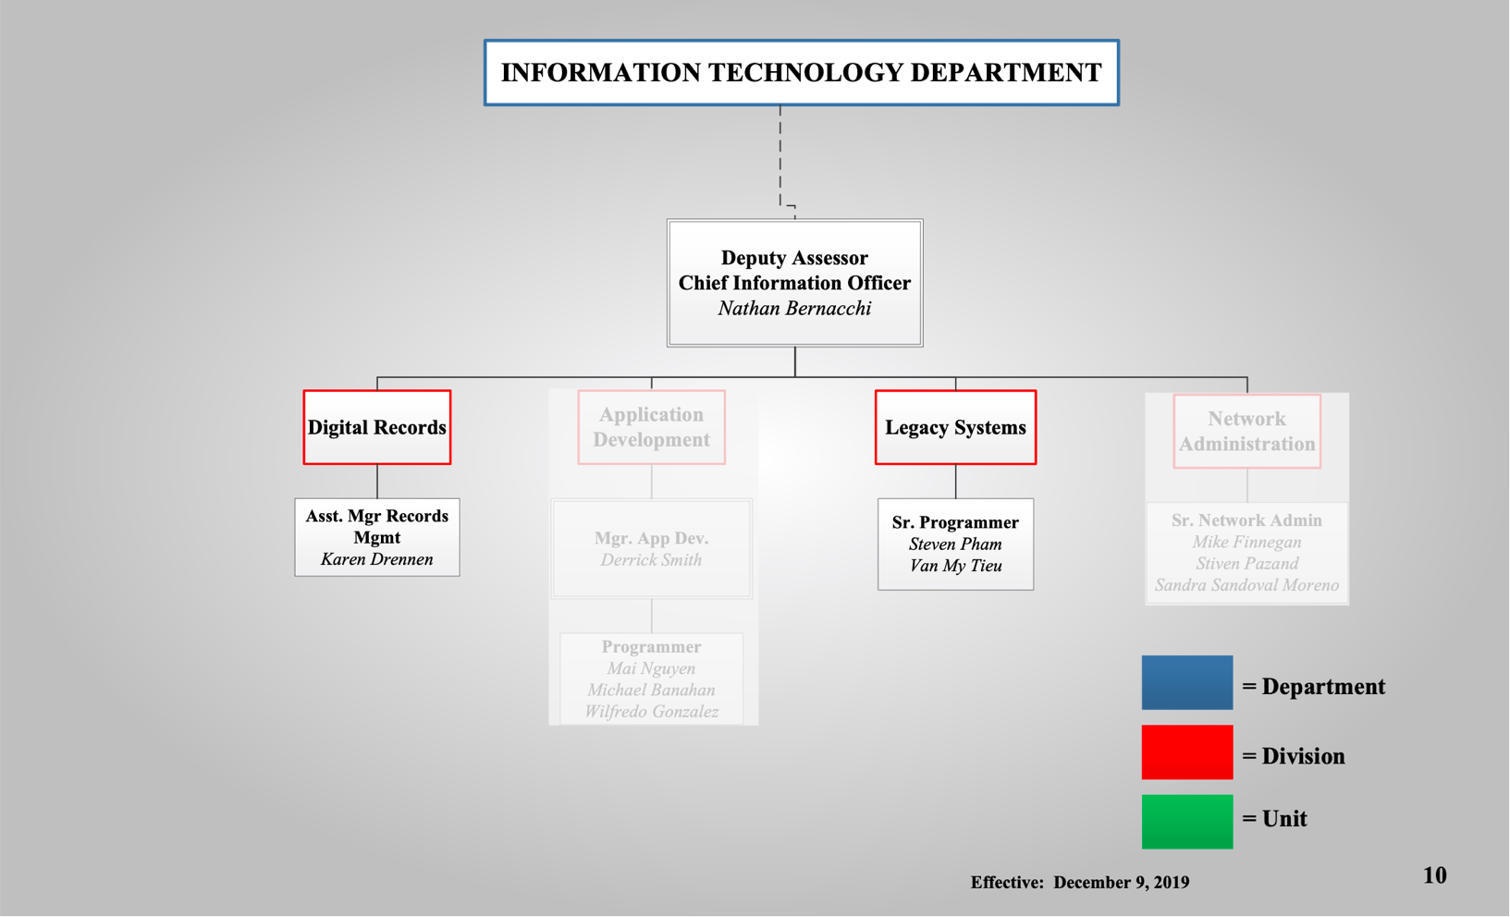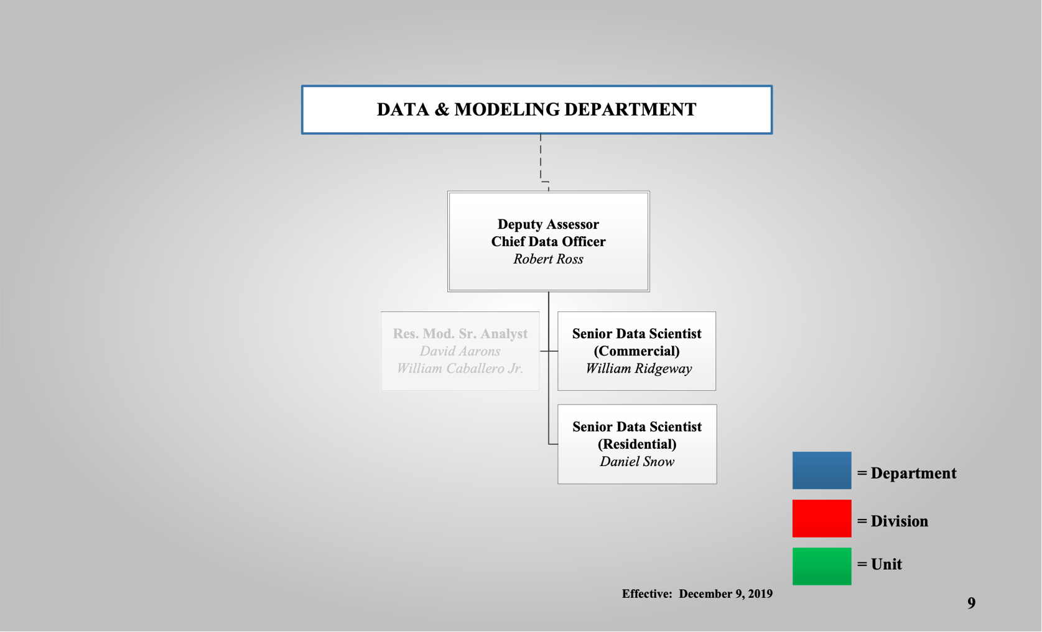

Interview Protocol

**The Interview**

* Two UIC Capstone Team members will be present at all interviews.
  + One member should be designated “primary” and the other “secondary”
  + Team members should be expected to share equal work burden in conducting interviews and filling the role of primary or secondary interviewer, to the extent possible.
  + Primary interviewer is in charge of questioning and recording (mp3 files)
  + Secondary interviewer is in charge of note taking, transcription, and source data management (organizing supporting documents). This includes taking specific note of materials to be gathered and following up on their procurement.
* The Primary interviewer will email the interviewee a list of topics to be discussed (“interview questions”) at least 24 hours prior to the scheduled interview time.
* In this pre-interview email, the interviewer should include in the body of the email the plain language of the privacy policy discussed below.
* The UIC Capstone Team members will meet 10 minutes before the beginning of the interview to make sure they are prepared and will arrive at the place of interview together.
* The UIC Capstone Team will begin each interview by generally delivering this scripted information about background/context for the project as well as some information about the interview itself:
  + “*Hello, thank you for taking the time to participate in this process. [introduce selves] As you may know we are working with Robert to document the exemption process so that going forward there can be more effective use of data to reduce the number of wrongful exemptions and help citizens get the exemptions they are entitled to. We will be asking some questions to guide the conversation, but please do not feel as though you are constrained by the questions. We want to gather as much information as possible.”*

## 

**Questions**

1. Please describe to the best of your ability the entire exemption process from start to finish for residential exemptions.
2. Please describe the features of the exemption process administered by your department.
3. How many people are involved in these tasks?
4. Generally, what is your specific role in processing exemptions?
5. Typically, how long does it take for you to do your part of processing exemptions?
6. What circumstances affect your part of processing exemption?
7. What sort of documentation process do you have in place to ensure tasks are accomplished?
8. What written materials do you have access to that would help explain the process?
9. Who else would you recommend that we consult?

**Post Interview**

* UIC Capstone Team debriefs the meeting, comparing notes and identifying information that is especially significant and illuminates what the team should be looking for in subsequent information gathering.
* UIC Capstone Team reviews and clarifies notes and uploads them to them shared drive.
  + Raw notes taken during interviews should be preserved in original form
  + Summary of one page or less should highlight relevant findings
* Filenames and locations are logged in master data inventory
* The secondary interviewer will email the interviewees within no less than 24 hours, and ideally within 12 hours, of completion of the interview. This email should contain:
  + In the email body:
    - A message thanking the interviewee for their time, and a request to view the attached materials for accuracy
    - A polite request for the source materials determined to be relevant to the Capstone Team’s mission, and any other relevant information forgotten or otherwise excluded from the interview
    - Instructions on how to deliver materials to the Capstone Team
  + Attached to the email:
    - A high-level summary of the interview, as will be included in the data inventory
    - Notes taken during interview

**Privacy**

* Capstone Team will follow UIC IRB protocol for human subjects research data management practices.
* The privacy of each interviewee will be treated with the utmost care
* Interviewees will be asked for their explicit permission for direct quotes to be used in any derivative materials, otherwise they should consider these conversations to be “on background”
* Any information shared by the interviewee will be made available in raw form only to:
  + Members of the Capstone Team
    - Matt Amann
    - Carter Craig
    - Tim McMahon
  + Capstone Program Director, Dr. James Thompson, UIC
  + CCAO Project Manager, Deputy Assessor Robert Ross

Interview Summaries

**Lumni Likovski, Director of Taxpayer Services**

**Hazel Fraiser, Assistant Manager of Taxpayer Information  
Date:** February 6, 2020 at 10AM

**Role:** As Dir. of Taxpayer Services, charged with overall Communications; Checklists for mailings; Specific dates, instructions, necessities: must check; Changes in legislation.

**Summary:** Seniors start with a “master list” of qualified seniors (automatic if on list). Public data from the IL Dept. of Public Health, SSI and Cook County is used by CDO to match name and birthday, death certificates (could include claiming exemptions to resolve property ownership), and to add new people (from turning 65 or from prior year certificate error), and remove sold homes via sales analysis. This master list is used to mail people prompting them to pursue their exemptions.

There are three mailings for senior freeze renewals: those that qualify being less than $65k per year, an initial freeze of EAV from first qualification, or requalifying from initial frozen amount (spouses can maintain). A statutory termination notice is sent in the event a qualified person died. Homeowner exemption booklet is mailed to most addresses. If old exemptions are removed, a new homeowner must reapply. If someone has not had an exemption in three or more years they no longer receive the booklet.

Other exemptions include **Persons with disability** ($2k EAV savings, Continuation, 12 mo. Of disability), **Veterans disability** that’s updated annually (Service connected disability rating <50% $2500 EAV / 50-70: $5000 EAV / >70% completely exempt up to $250k) and **long-time occupant** (homeowner exemption; then 7% increase every year / Make less than 75k for 7% / Live longer than 10 years /100k /10% increase /Doesn’t count if you change the size of the house/addition).

Most applications for exemptions arrive by mail to a vendor, who processes the vast majority of applications. The mailers ask that individuals email their application to the vendor, who is located in Dupage county. These applications are scanned into a system as PDFs, and applications are assigned a bar code. That bar code is used by the CCAO to upload that exemption data to the main frame. A smaller number of applications are sent directly to the CCAO where they are processed along with “counter forms” filled out by individuals who come in person to the CCAO office on the 3rd floor of the Cook County Building.

The last step in the process is to add up all exemptions and send them to the clerk, who adjusts the jurisdiction value. The state then sends the equalizer and the Clerk equalizes value to state based on the multiplier (different calculation of AV from county to county). The clerk accesses the information through the mainframe. Districts/governments then send levies to the clerk and the clerk calculates rates and sends levies to taxpayers.

About 100k certificates of error are processed annually. If the exemption window has closed, only bills can be adjusted and must wait after being calculated turning into a separate legal process.

TP Service staff includes 39 staff, 10-14 mail bins during peak, exemption processors that process up to 3 years back, and three satellite offices in Markham, Bridgeview and Skokie with 3 people in each office.

**Nicole Jardine, Director of Communications**

**Date:** February 6, 2020 AT 12 PM

**Role:** The communication department drafts letters for mailings (not via state statute), conducts outreach with a staff of 5 people where they can accept but not process forms. Use tools like PowerPoint to show the process if an exemption is not taken, purple book that contains big three, and gold for deceased, and blue for senior freeze. There is also an online system (away w TYLER) that uses the vendor DocuSign.

**Summary:** Some mailers are for people with renewals and some are first time applicants. Mailers and forms are aligned to the same schedule. The big three exemptions are senior, homeowner and senior freeze. All internal processing items and messaging due on May 1st so that the clerk can calculate and issue tax bills. After that, things are processed as a certificate of error (COE) and it comes out of levy.

Goal is to reduce COEs, reflect standard operating procedure of accepted ID into form, and move senior and homeowner to separate forms. Past form had senior and homeowner on the first form, a lot of people didn’t know their PIN and the forms were redesigned to be more user friendly.

**Justin Kirvan, Legal Counsel**  
**Date:** February 7, 2020 at 12PM

**Role:** Primarily deals in legal statutes side of the process. When Lumni gets an edge case with something strange - consult statute to figure out the best approach. Assisted in redoing forms of big three. Effort to make them clear and legally sound. Took existing form and ensured legal statute was required and met. Forms are currently only SOP - coded into the forms. No discretion as to what the requirements are. No enforcement mechanism to audit. Can be an issue with taxing districts.

**Summary:  
Appellate Case:** The Appellate Court took a case where the assessor's office required proof of paying taxes in order to receive a homestead exemption. The assessor’s office wanted to use this as a standard operating procedure, but the court ruling said they did not have the authority. According to the statue, all that’s required is that they live there. Taxpayers appealed a denial from Rock Island Assessor and it was upheld. Cook County was using the same method. Then had to immediately cease and desist practice.

**Edge Cases:** Legal Dept. in process provides overall overview of cases and then gets involved in edge cases with TPI when necessary. Edge cases feed up through the department and are forwarded to the legal department at Lumni Livoski’s discretion. Two attorney’s are involved in exemptions: Justin and Tasha. Act as consultants. Edge cases are usually very specific and really ask how much documentation is needed for that specific case. Roughly 150 of such cases a year.

**Legal Memos:** Two to three legal department exemptions memo a year in response to a court case or change in a law, such as the senior citizens exemptions auto renew. Memos are saved internally. The legal department has a final review as well the communications department for drafting purposes. The Chief of staff or Assessor does not review this information.

**Mark Kos, Director of Freedom of Information**

**Date:** February 10 at 1:00 pm

**Role:** FOIA is an access point for professionals to interact with the exemption system. Added layer within CCAO to provide transparency and to separate walk-in residents from industry professionals.

**Summary**

**Automation:** Statutes are the main source of directive. Once the process is automated (docusign) probably all of the errors will start to go by wayside and find that exemptions are being administered properly and a number of COE’s will come down.

**Process:** A piece of paper that drives the process. Literal paper goes to FOIA office (batch mindset) HUPD (Homeowners Update Daily - follow-up with Lumni - literal process of data entry). Enter the index number and information attached to the applicant. Pushes the information into the workflow. Lumni will push batches back and forth to put all of the proper exemption types into right files. Homeowner, senior freeze file, all need to go into a larger file. If not, the applicant will not get a full picture of exemptions. Goes to tax exemption to create the tax bill. If info stays in a temporary job/tax bill then a taxpayer may have no idea they have to file a certificate of error.

**C5. Steve Pham, Legacy Systems Senior Programmer**

**Date:** February 14 at 2:50 pm

**Role:** This individual uploads most exemptions to the mainframe roughly once per week.

**Summary:** The Vendor sends a data file with a batch of roughly 10,000 PINs and DOBs each. Senior Freeze and Veteran come in by batches that are separated by their mean-tested qualification. Pham uploads Senior, Senior Freeze, and Veterans. The other’s are handled “by Lumni’s People.”

**C6. Martin Paulson, Special Projects**

**Date:** February 19 at 3:00 pm

**Role:** Former Lake County Assessor currently assisting CCAO in TYLER transition.

**Summary:** Starting in 2019, Lake County started using an EFile tool, Smartfile, a feature of TYLER. Went live in 2018, started using file features in 2019. Cook has a different app for that. (docusign). The online form saves a lot of work because those fields translate directly into the database. Would mean that there is no/less need for a vendor. In Lake County they were able to continually streamline their process within TYLER. i.e. removing a sort of task gatekeeper.

Biggest problem, bottleneck: The time it takes to process exemptions.

Proof and income take time for people to process that info. Sometimes that info submitted is wrong. That back and forth takes a lot of time. Often demands a lot of labor. EFile and other online tools do help a little bit by prompting users to provide all necessary documentation but evaluating applications takes time. Tyler Technologies implementation has been rockier here. In Lake county, a data jump from a mainframe to a client server has already been made. Change happened a little easier in Lake County for a variety of reasons.

**C7. Mirella Villafuente, Special Projects**

**Date:** February 19 at 2:00 pm

**Role:** Special Projects advisor serving as project lead on Tyler transition. Not involved in daily processing of exemptions, but source of aggregated information about interdepartmental coordination at the CCAO.

**Summary:** This interview focused primarily on the AS-400/Mainframe processes and the hard deadlines and how they affect the timing of other tasks. A great deal of the information relating to the mainframe is with those who work in legacy systems. Provided the interview team with a process map and answered questions as needed. The mainframe necessitates knowledge of COBOL programming language. Everything needs to be ready for the printing of the second installment of tax bills on August 1st. That necessitates a series of intermediary deadlines in the residential exemption process.

Now lead on Tyler project. Said they could get it done in five years, laughed, more like ten most likely problems are dirty data, complex setup. Clarification: MF always == Mainframe, Master File reference: resides in mainframe. MF is “property tax system of record” that is depended upon by other agencies that use property values (Treasurer, Clerk, Assessor) Often, legal action will need to copy all three to ensure they update their “piece” of the data. MF is non-relational, AS400 is “db2” quasi-relational logic. HUPD == screen that is used to update MF “Homestead UPdate Display.

Systems == IT side of things. CCAO is working on two or more technology systems at any given time. Individual workers often pull data into spreadsheets or other programs to work with it, as the direct interface necessitates programming skills in COBOL

Team of “Legacy” database workers: (IT – Legacy Systems) Karen Drennan: Asst. Manager Records Management. Steve Pham: Senior Programmer III. Van Tieu: Senior Programmer III. Raul Moreno: old guru of MF, AS400 query architect, broad knowledge that was not transferred before retirement indicative of lack of knowledge/familiarity after leaves assessors office.

In order to use data directly off the mainframe: BOT runs queries and reports for others by physically printing stacks of paper. All very manual – on the 7th floor literally printing reports. Then runs “analytics” on these paper reports looking for problems. Their “jobs” apply equalizer and then exemption, components are PIN, exemption amount, complicated when exemptions are based on value. MV has spreadsheet of JOBS run on MF Who else is involved? Tracey Boswell (MIS) - assessor processing, Tom Brown (MIS) – not sure what he does What are the problems? Besides the nitty gritty BOT stuff; Missed exemptions, not communicating enough, people do not file and show up when bill is due, “Wasn’t expecting it to be this high! Help.”

Backwards Hamster Wheel: 2nd property tax installment DUE 8/1. Preckwinkle: Amendment of statute with due dates, but dates for sending bills are not compelled, In order to give people time to pay: treasurer must send bills by 7/1, This means extensions must be sent from clerk by early June. Extension = property EAV * rate. Rate = total EAV * levy Mirella: this is a crazy time at the clerk’s office: dealing with all properties, not just residential. All sorts of incentives, TIFs, etc to check and administer. Clerk cannot generate rates without full jurisdictional EAV. Meaning late APRIL is when EAV needs to be sent to them. Exemptions are taken off individual EAVs at this minute point. EAV = calculated AV * state equalizer. But to get state equalizer: CCAO needs to send full AV to IDOR, for some reason does this in two “batches”: Preliminary is right after the Cook County Board of Review (BOR) closes with certified valuations, final is after BOR and valuations have been reconciled. Mirella: not much change between these two “chunks.” So to do all of this: BOR must close by 4/1, However, this is dependent upon the volume of appeals, and if this first step in the chain is often delayed… Crunches everything down the line. Lots of stress: no one wants to pick up the blame for being late.

CCAO Internal Exemption Process Map & Verification Requirements

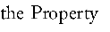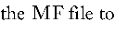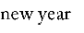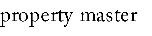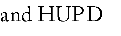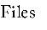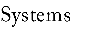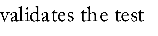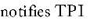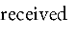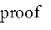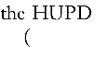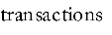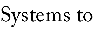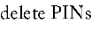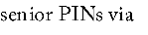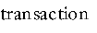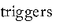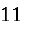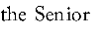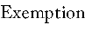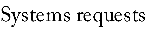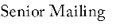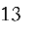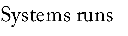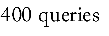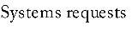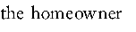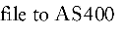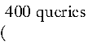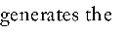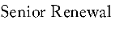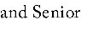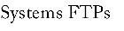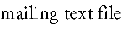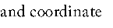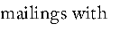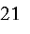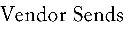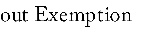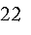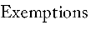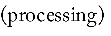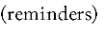

Predecessor: BOT and Treasurer Process

Prepare and Test File (prior to application intake)

Removal of Deceased s PIN # from Senior File

Mailing Process

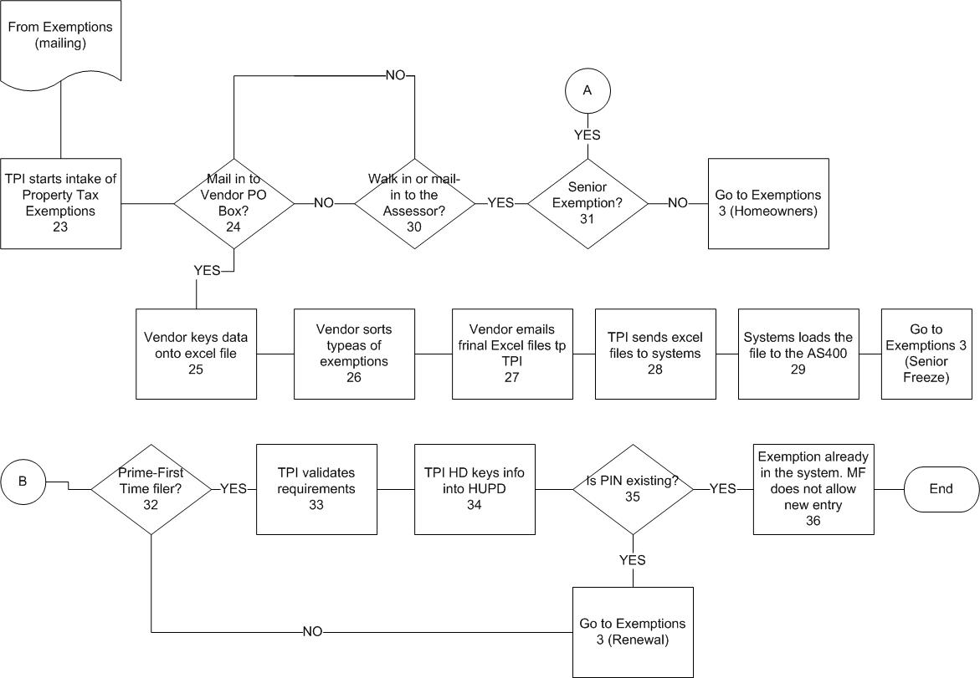

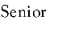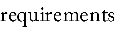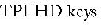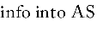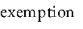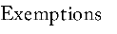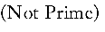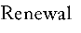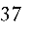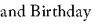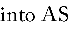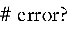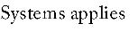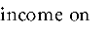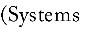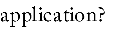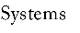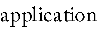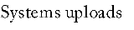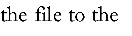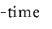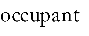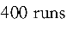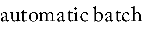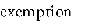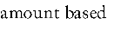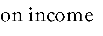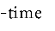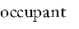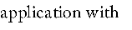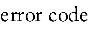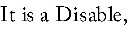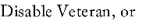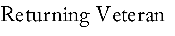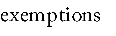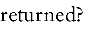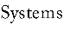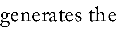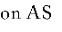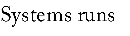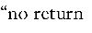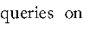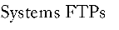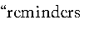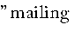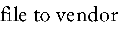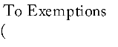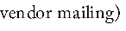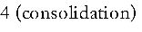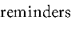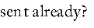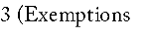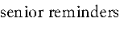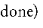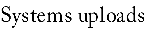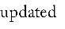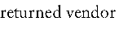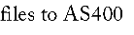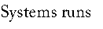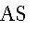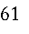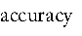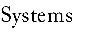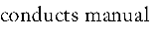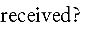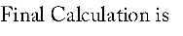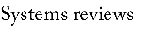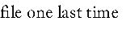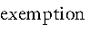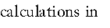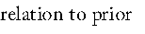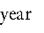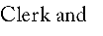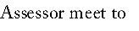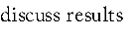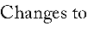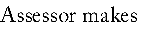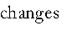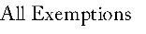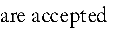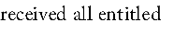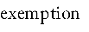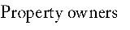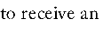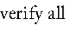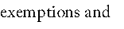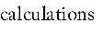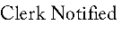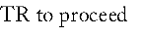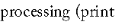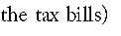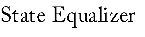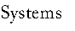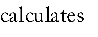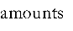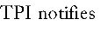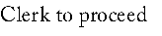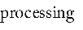

Exemptions Consolidation





Gantt Chart: Schedule & Relationship Dependencies





Mailing List Decision Tree and Notification Design

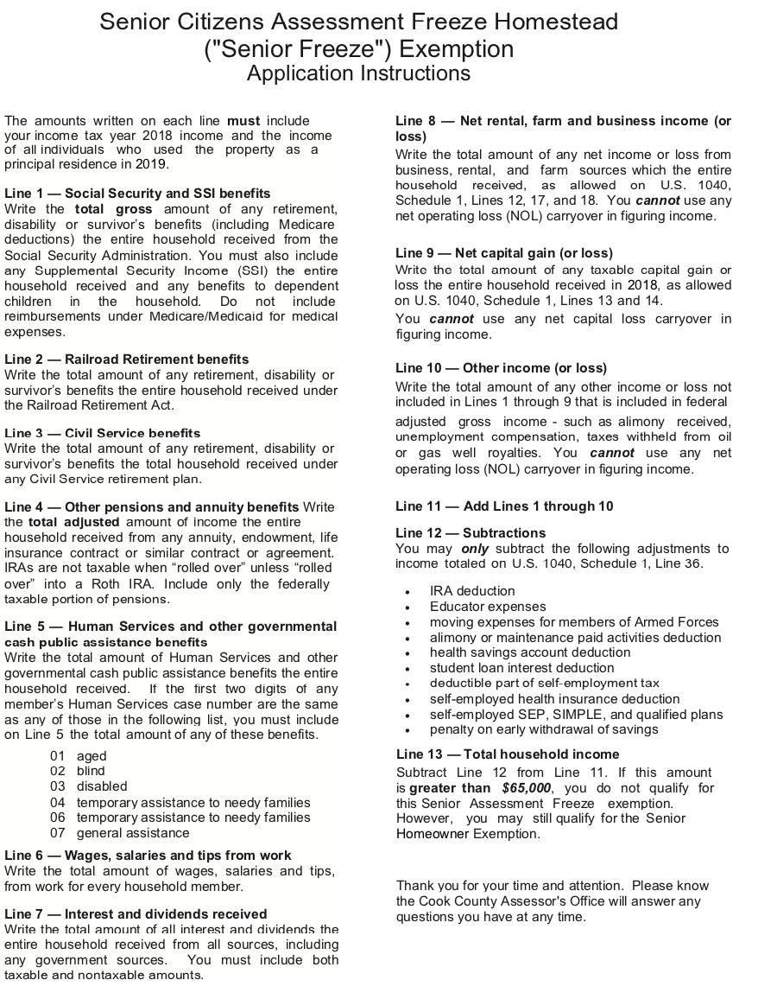

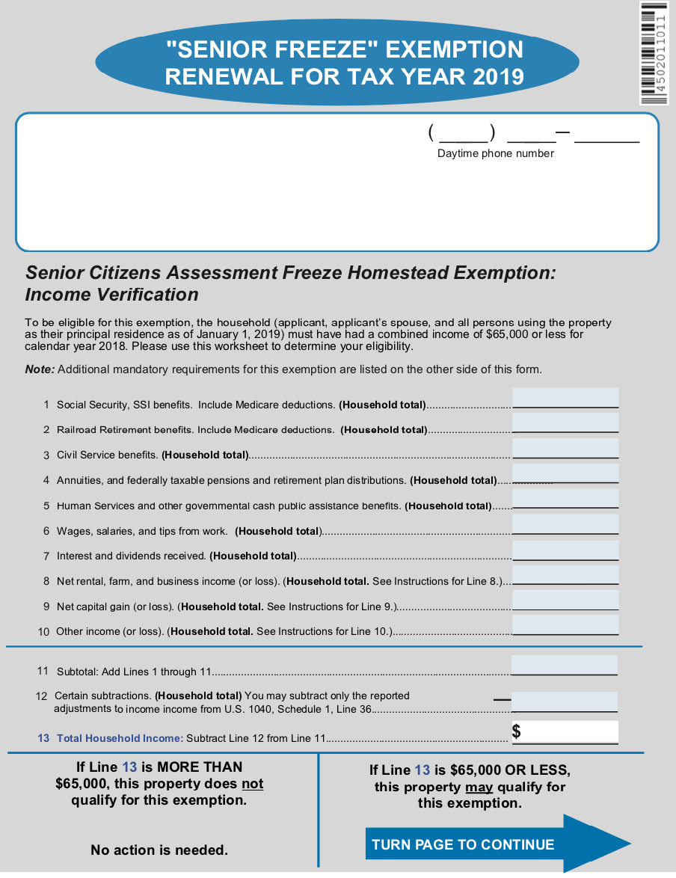

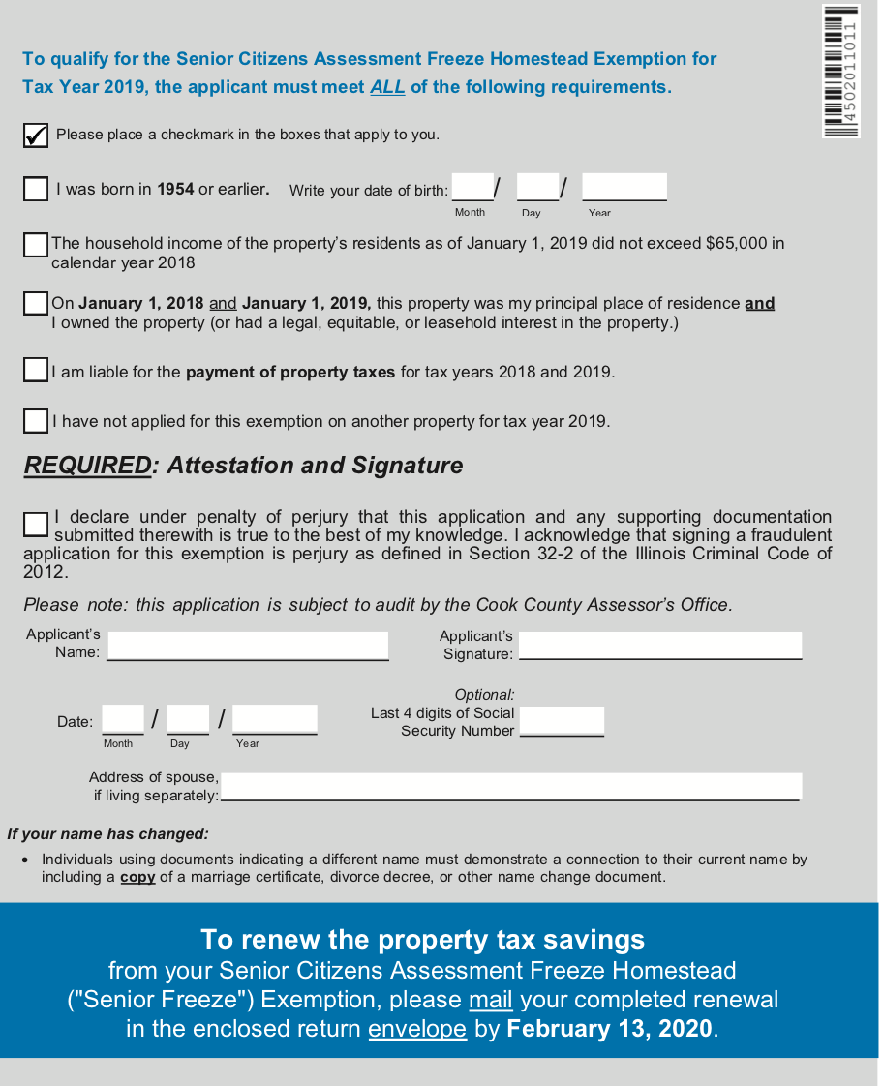



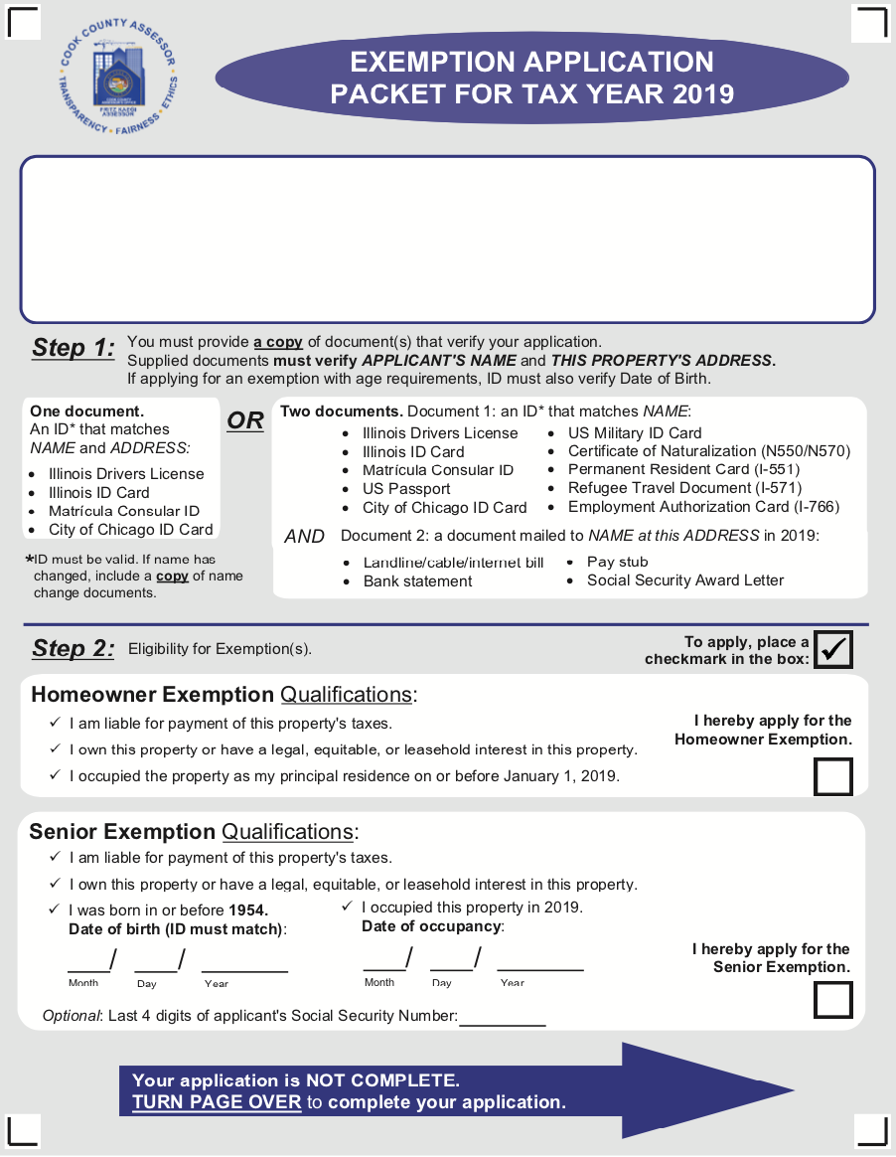

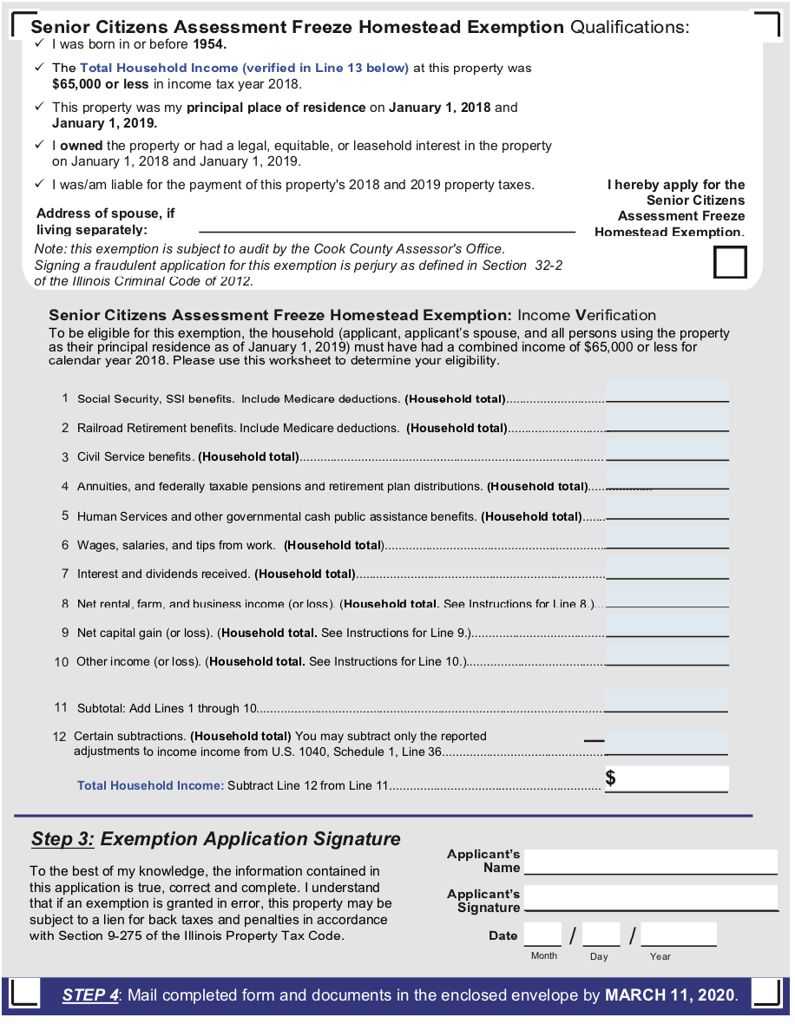



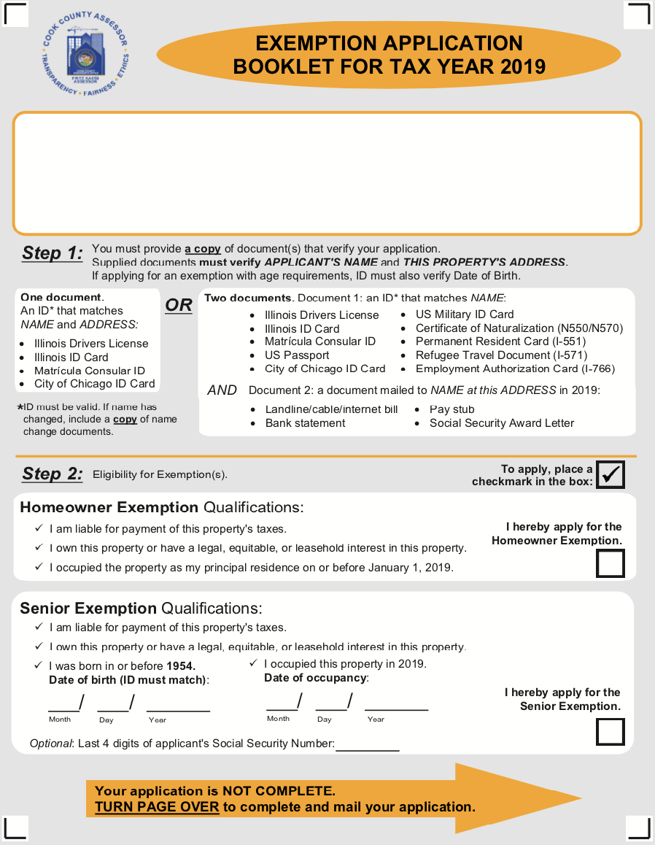

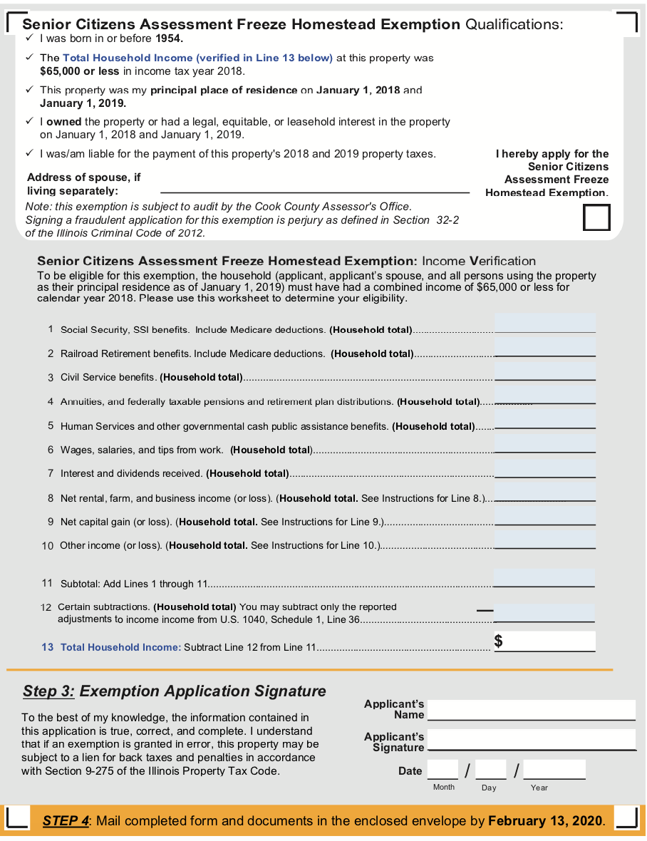

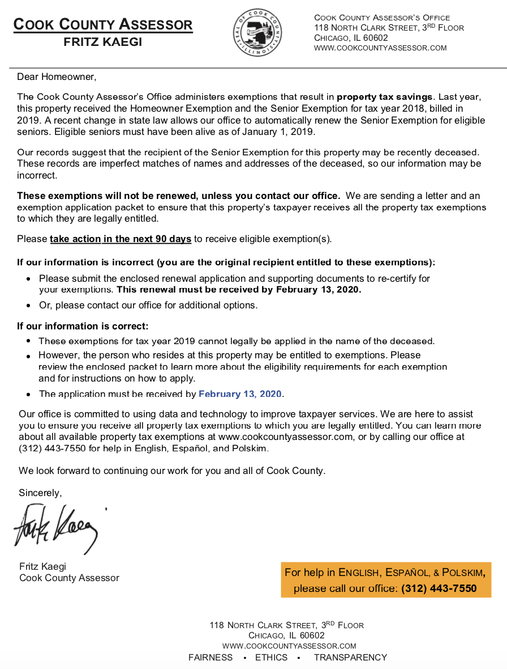

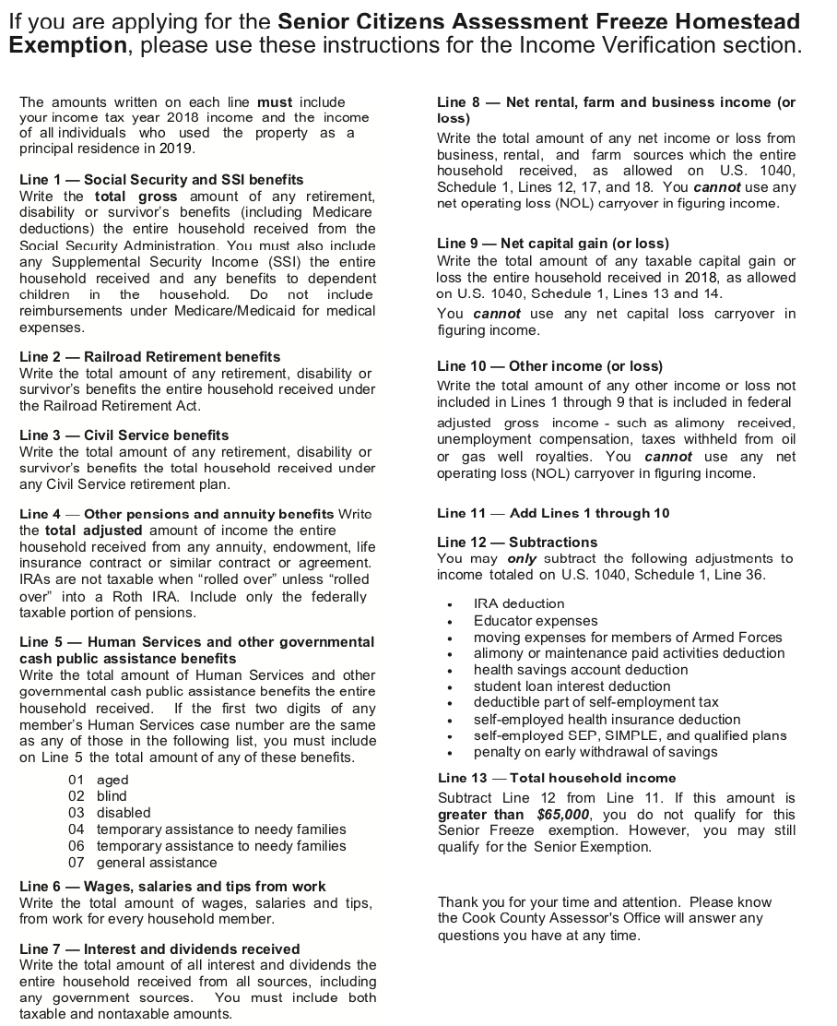



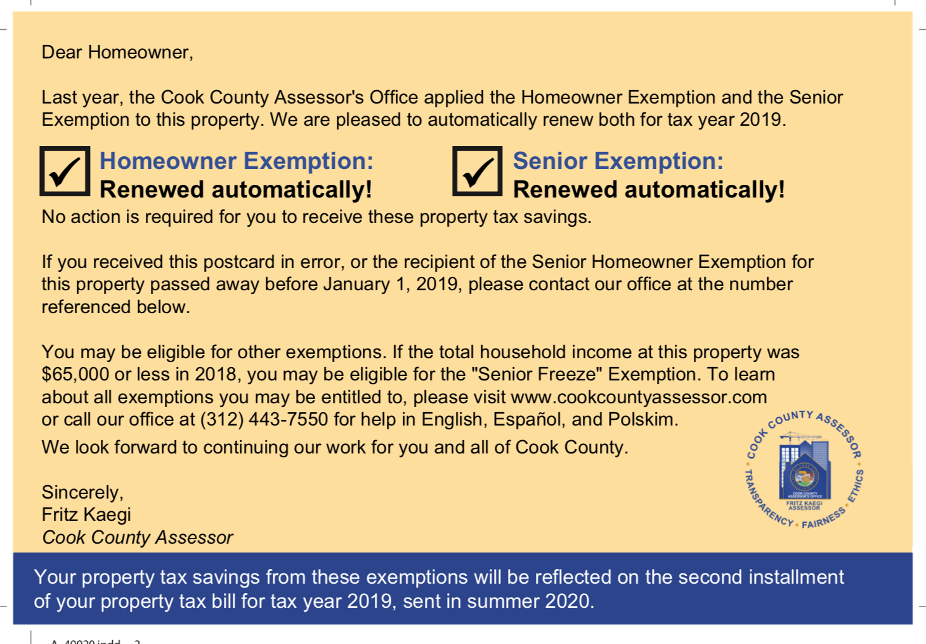

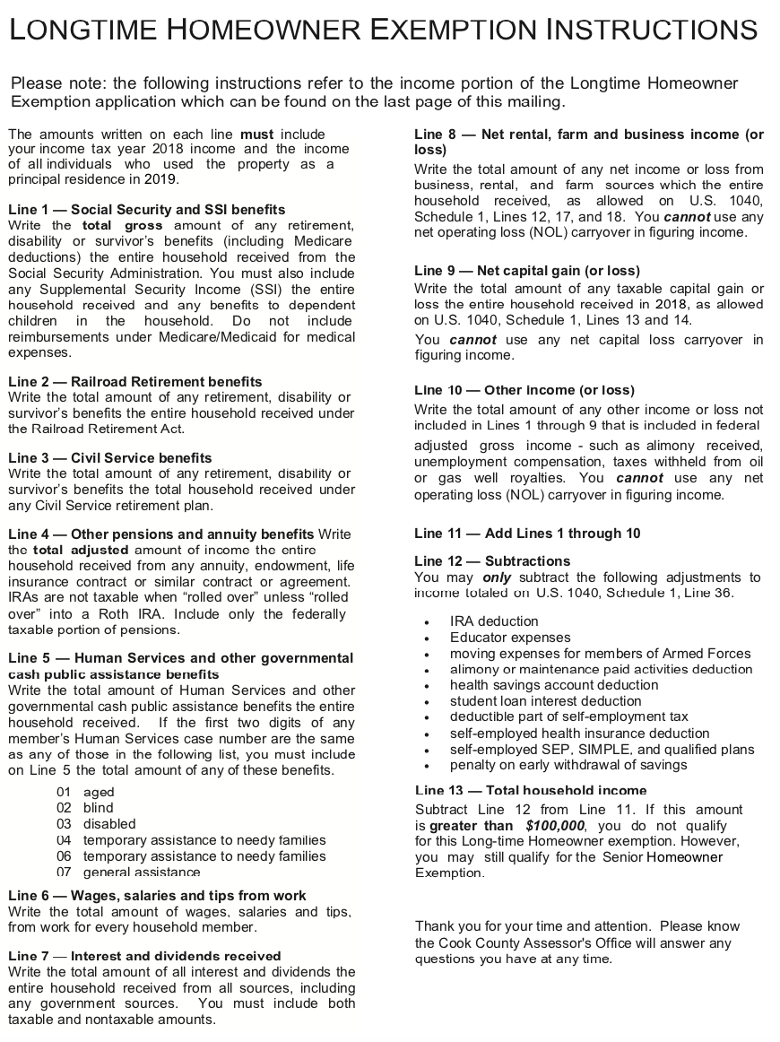



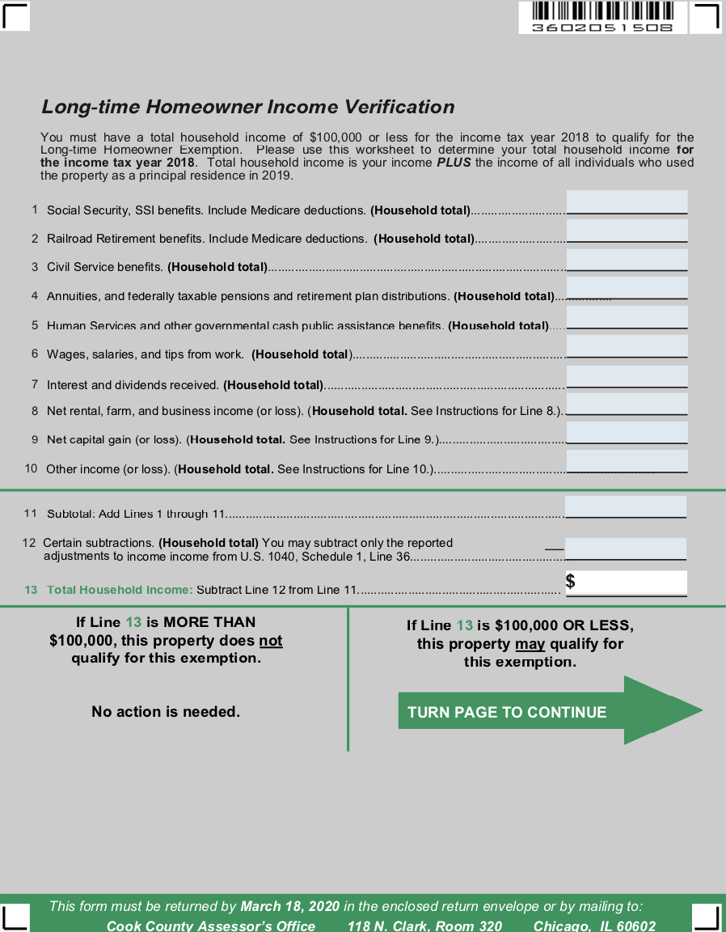



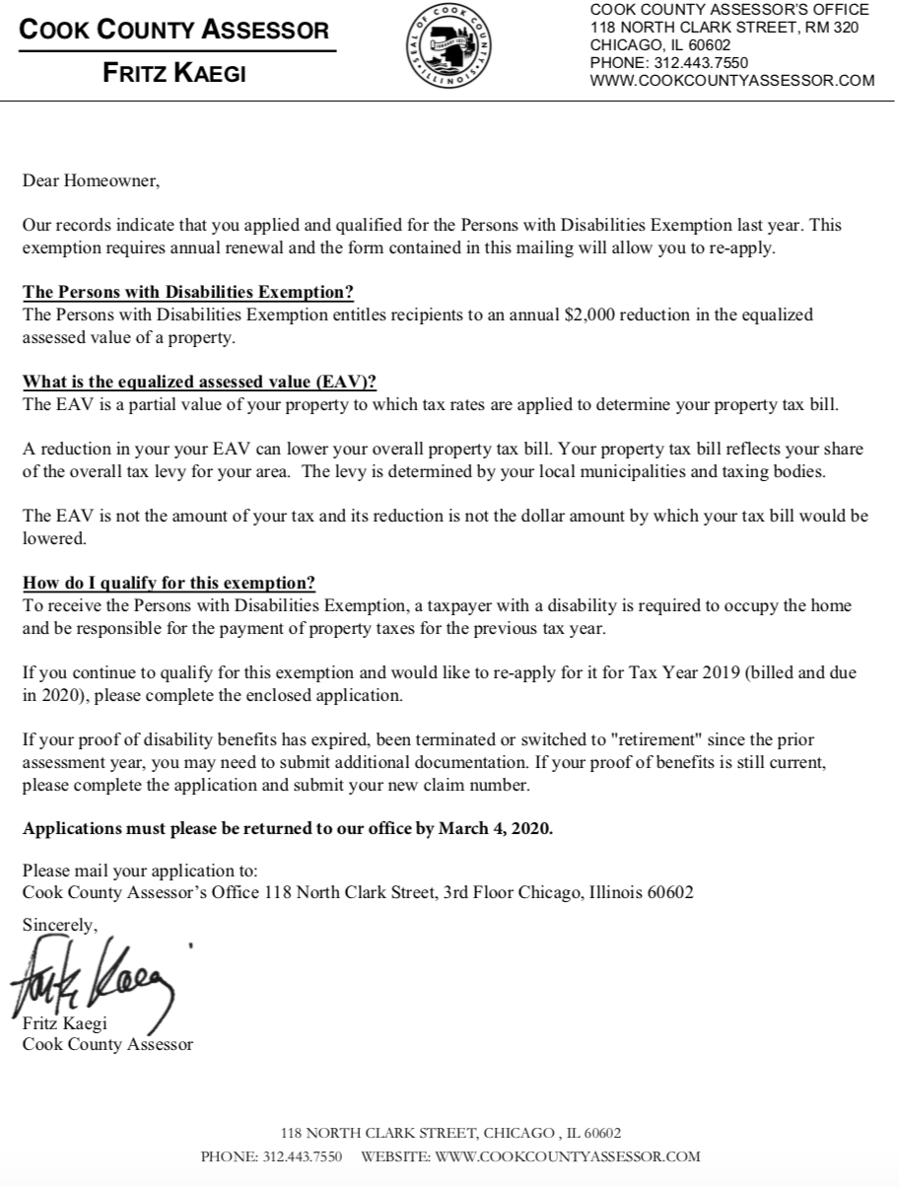

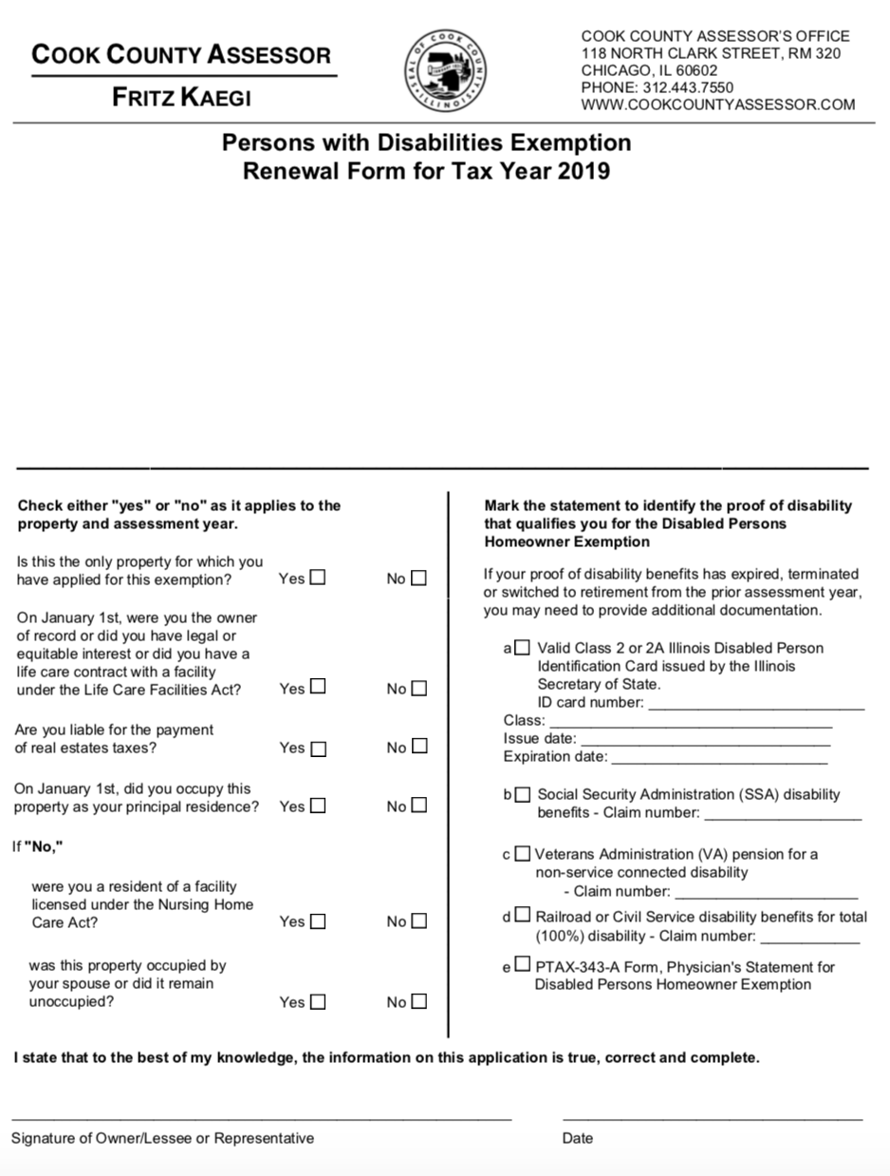

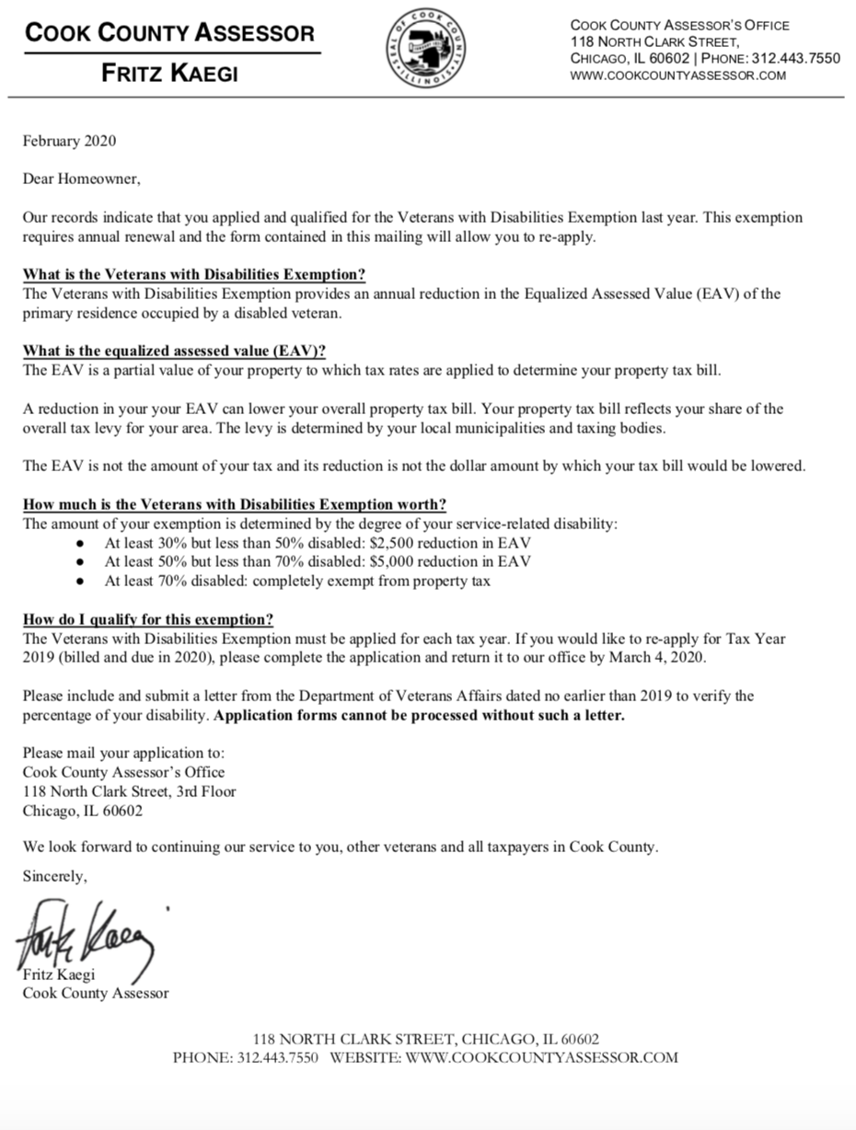

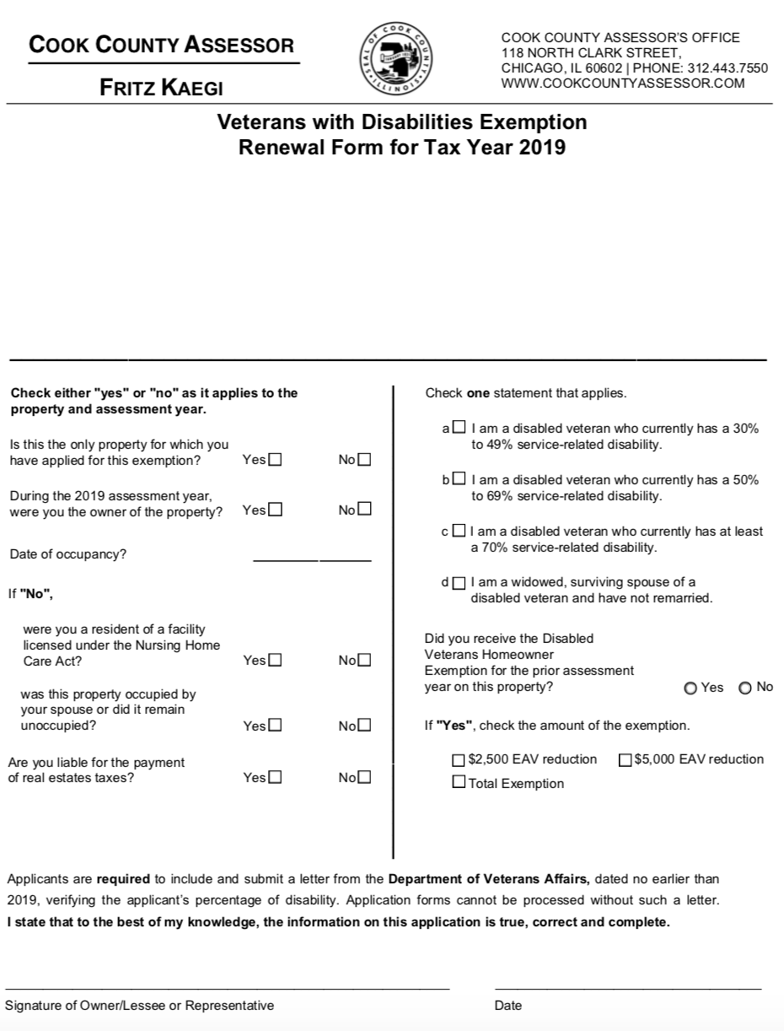

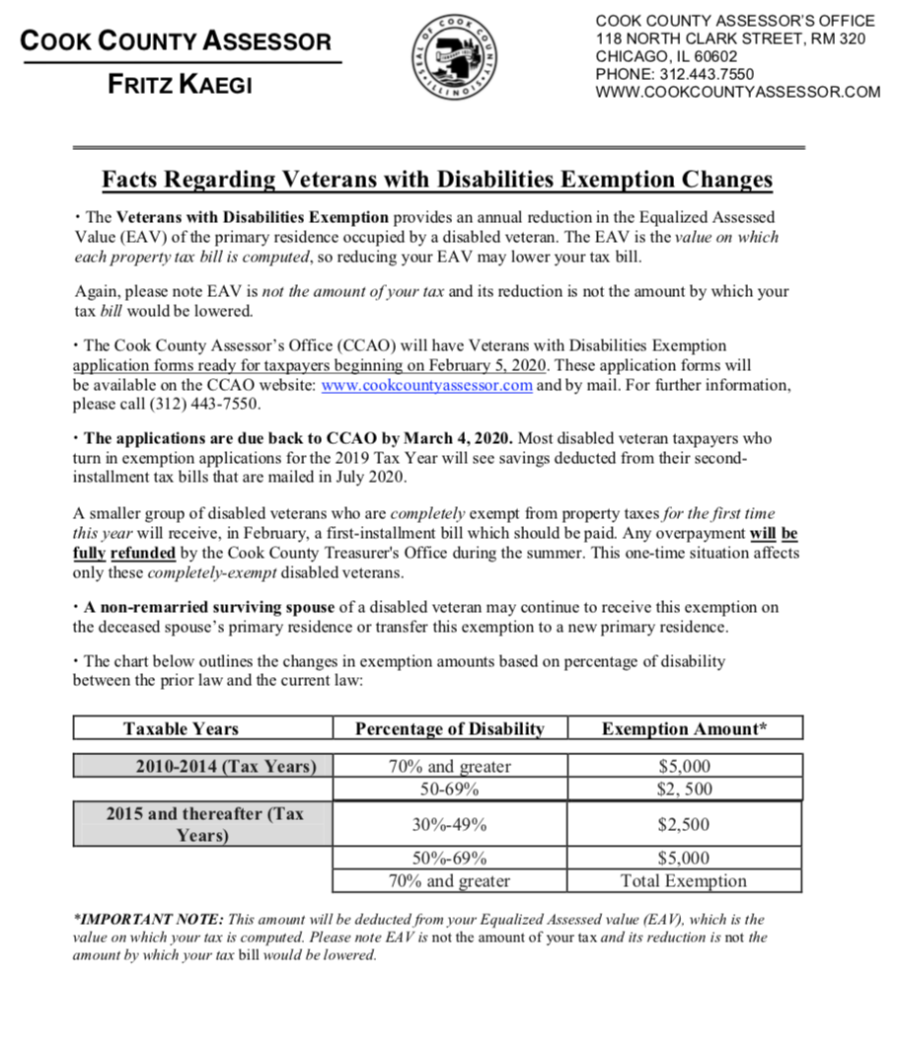

HTML Reference Tool Details

**Overview**

Property Tax Exemptions 101

**The Assessor’s Office processes seven types of property tax exemptions.**

1. Senior (a.k.a. “homestead”) – processed in the mainframe (MF);
   * A Senior “Prime” Application refers to a first time applicant.
   * If it is not a “prime” application, then it a “renewal.”
   * Renewals are processed on the AS400.
2. Senior Freeze – processed in the AS400;
3. Disabled person – processed in the AS400;
4. Disabled veteran – processed in the AS400
   * For three categories of disabled veterans:
   * 70% disability or greater
   * 50 to 69% disabled
   * 30 to 49% disabled
5. Returning veteran – processed in the AS400;
6. Homeowner – processed in the AS400;
   * Co-ops and prorated parcel exemptions are uniquely calculated
7. Long-time homeowner (or Long Term Occupant) – processed in the AS400;
8. Other

**Order of Operations for Exemption Deductions**

1. Senior Freeze
2. Homeowner
3. Homestead non-Coop
4. Veteran
5. Homestead Coop
6. Disabled Person
7. Disabled Veteran < 75%
8. Disabled Veteran > 74%
9. Returning Veteran

**Note**: Given limitations of the mainframe, exemption applications are grouped in batches. In practice, the initial entry of Senior and Senior Freeze Exemptions uses batch numbers 000001 to 000005; one batch per branch including downtown.

Senior renewals are captured in the AS400 and thus batch in a simpler manner, in sets of 100 records, each group of 100 gets its own batch number (to make it easier to search and retrieve). The County requires the elimination of these limitations.

While some exemptions are captured and processed in the AS400, all exemption information is subsequently uploaded to the mainframe. Assessor’s Office does not apply exemption amounts directly, but rather to the equalized assessed value (EAV) after this has been determined by the Illinois State Department of Revenue.

**Changes for Tax Year 2019**

Updates to forms and processes

| **2019** | **2020** |
| --- | --- |
| “Senior Citizens Exemption” | Renamed Senior Exemption |
| “Disabled Veterans Exemption” | Renamed Veterans with Disabilities Exemption |
| “Disabled Persons Exemption” | Renamed Persons with Disabilities Exemption |
| No exemption applications were available online. | Homeowner, Senior, and Senior Freeze are online. They are linked on each exemption’s web page. |
| Exemptions: accept/reject via the mail. | For online applicants, notification via email. |
| Taxpayers with leases applied for exemptions via Certificates of Error. | Can apply for current tax year (must see a manager). |
| Occupancy Affidavit: attestation by someone other than applicant. | Applicant now attests to their own occupancy of the property. |
| Homeowner and Senior Exemptions were on the same form. | These exemptions are now on separate forms, as they have different eligibility and document requirements. |
| Listed accepted ID documents: drivers license, state ID. | Lists are greatly expanded to match eligibility requirements for ID, occupancy, and taxpayer status. |
| Must renew Senior Exemption every year. | Now the Senior Exemption is renewed automatically. |
| Didn’t ask for last 4 of SSN. | Senior and Senior Freeze forms request (optional) the last 4 of SSN. |
| **Mailers:** Two senior-related mailers: *purple* “full” booklet for deed changes (Homeowner, Senior, Freeze) and the *blue* “senior renewal” booklet that included the Senior and Freeze. | This “Senior” group was broken into 3 categories. *Blue* mailer: modified to just renew the Freeze. *Gold* mailer: new. Is the “full booklet” renewal mailed to prior recipients of the Senior who may be deceased. *Postcard:* new. Confirms Homeowner and Senior auto-renewal so that no action is necessary. |

**Resources for taxpayers**

* Link directly to https://www.cookcountyassessor.com/exemptions
* Site contains a brief overview of all exemptions, with links to each one
* Lists the documents required with application
* Printable PDF applications and online submission available when possible.
* It has important notes for anyone applying for exemptions

**1. Generate Master File**

| **Departments Involved** | **Programs &  Technology Employed** |
| --- | --- |
| Bureau of Technology (BOT) | Mainframe |
| Taxpayer Information (TPI) | Homestead Update Interface (HUPD) |
| Data Science | AS400 |
| Legacy Systems |  |

**Description**

**Generates list of taxpayers who are likely eligible for exemptions (“Master File”).**

**These will be informed of their eligibility, status and the next steps to take to receive their exemption.**

**Details**

**1.1.** Create a copy of last year’s Master File for use in current tax year

* Backup prior year HUPD file
* The file is updated nightly with assessment and exemption information from Board of Review data sets.
* PTI: Change the nightly back up (new file scheduler)
* BOT: Enable HUPD transactions on Mainframe
  + HUPD is a program that interfaces directly with the Mainframe
  + TPI can use it to update the records directly
  + HUPD is technically a noun, but is often used as a verb as jargon for “use the HUPD to access the Mainframe”
* Associated files, programs & naming conventions
  + Conversion program: TRIPT761
  + Panvalet record description: ASREASRDU3
  + Run-A-job: TRIPT63T
  + FTP file name example: AS.REA.ASMTMSTR-MF-120817.TXT
* Data dictionary & documentation
  + as.rea.asmtmstr.csv
    - NB: each field is interspersed with a ‘|’ delimiter, omitted here.
    - Original (S. Pham 2017)
  + The Assessor property master is a **VSAM** file that has detail segment data for all Cook County properties: land data, improvement data and questionnaire data.
    - **V**irtual **S**torage **A**ccess **M**ethod, IBM data structure circa 1970.
  + The file name the mainframe uses is AS.REA.ASMTMSTR
  + The converted output file will be a variable length file.
  + Bytes 1 – 273 will always be on each record as defined below.
  + File length is variable.
    - After byte 273, the data format will vary depending on what variable segments the records will have.
    - Minimum length is 273.
    - Maximum length is 273 + (118 * 200) = 23,873.
    - 118 is the variable segment data length for all segments
    - 200 is maximum number of segments.
  + Each record can three distinct types of segments all 118 bytes in length. They are:
    - *Sales segment:*
      * This segment can exist only once on each record.
      * You must inspect the value of ‘Sales segment counter’ in byte 264.
      * If the value is ‘zero’ then the record will have no Sales segment.
      * If the value is ‘one’ the record will have a Sales segment.
      * The Sales segment, if it exists, will always follow the fixed data of the record.
      * It will always be in bytes 274 to 391 on the record.
    - *Detail segments:*
      * These segments can occur up as many times as the value in the field called ‘Detail/Questionnaire segment counter’.
      * There are five different types of Detail segments.
        + Type 1 – Land
        + Type 2 – Improvement
        + Type 3 – Improvement
        + Type 4 – Improvement
        + Type 5 – Improvement
        + In order to determine what kind of Detail segment you are dealing with you must inspect the value in the field called ‘Type’, which will be in the fifth byte of every Detail segment.
      * If no Sales segment exists, the Detail segment will followed the fixed data in bytes 274 to 391.
      * If a Sale segment exists then the first detail segment will follow it in bytes 392 to 509.
    - *Questionnaire:*
      * This segment will always follow directly behind a Detail segment if that Detail segment is either Type 2, 3, 4 or 5 and the Detail segment field called ‘Class’ has a value of 202-212, 234, 278, 295, 402-412, 434, 478 or 495.
      * The field ‘Class’ will be in bytes 13-15 in all of the Detail Type 2-5 segments.
      * When dealing with the variable segments you will have bump through the record after the fixed portion by 118 bytes as many times as the counters in the fixed portion of the record tell you in order to process all the variable data.

**1.2.** Removal of deceased taxpayers

* An application may return with a signature from an estate executor or, notification is received from a family member.
* An Executor must submit authorization to execute and Death Certificate.
* TPI works with Systems to delete PINs: uses the Exemptions homestead file from the prior year to remove deceased seniors or to make adjustments
* Data Science working to utilize other county and state databases to match ineligible taxpayers to properties

**1.3.** Open new tax year HUPD file

* Systems Department typically calls BOT to request opening of the Mainframe HUPD transactions sometime in October of every year, prior to preparing exemption mailings which start in January of the following year.
* This is in preparation for the exemption and tax processing. BOT opens a new year with no PIN numbers and updates the menu/options/screens to point to the new year - which is empty
* BOT downloads the Mainframe file to the AS400

**1.4.** Integrity & Quality Assurance Testing

* TPI keys 4 or 5 PINs for Prime applications (new senior applications)
* BOT runs a nightly cycle, and downloads the Senior and Homeowner File to the AS400
* Systems validates the test PINs and notifies TPI

**1.5.** New file reconciliation

* TPI enters all Prime applications received prior to mailing and applications received thereafter directly to Mainframe.
* BOT disables HUPD upon request from TPI, triggers appropriate jobs to update for all other users (e.g. Clerk, Treasurer)

**2. Generate Mailing List**

| **Departments Involved** | **Programs &  Technology Employed** |
| --- | --- |
| Bureau of Technology (BOT) | Mainframe |
| Taxpayer Information (TPI) | AS400 |
| Legacy Systems |  |

**Description**

**Use Master File to create list of addresses associated with potential exemption eligibility.**

**Details**

**2.1.** Build Sales File for mailings

* **Query Basis:** Properties sold in past year likely indicate change in exemption eligibility, if only from one taxpayer to the next.
  + Query syntax
    - RUN FOLLOWING JOBS TO CREATE PRIOR YEAR SALES FILE WITH SALES GREATER THAN 1 DOLLAR (VALID SALES)
    - Library DATAC

| **AS400 Query** | **Note** | **Input File** |
| --- | --- | --- |
| RMMSALEA | USE PRIOR YR SALES MD FILE | SELECT DEEDYYYY PRIOR YEAR |
| RMMSALEC | USE CURRENT YR SALES MD FILE | SELECT DEEDYYYY PRIOR YEAR |
| RMMSALED | IDENTIFIES DUPLICATE RECORDS | n/a |
| RMMSALEE | ELIMINATES DUPLICATE RECORDS | CHANGE YEAR IN ‘DEFINE DATABASE FILE’ TO PRIOR YEAR (E.G. SALE2017W0/DATAC) |
| RMMSALEF | SELECT SALEPRICE GREATER THAN ‘1’ | CHANGE YEAR IN ‘DEFINE DATABASE FILE’ TO PRIOR YEAR (E.G.SALE2017G0/DATAC) |

* Process in AS400

**2.2.** Create 10 year age property file

* This is used to calculate means-tested percentage exemptions
* **Query Basis**: has the taxpayer received the homestead exemption for at least nine consecutive years **OR** previously received a long-term exemption?
  + Query syntax
    - IF CURRENT TAX YEAR =TRI YEAR, THEN AGE =10
    - IF CURRENT TAX YEAR =TRI YEAR-1, THEN AGE=9
    - IF CURRENT TAX YEAR =TRI YEAR-2, THEN AGE =8
    - Library DATAC

| **AS400 Query** | **Result** | **Output File** |
| --- | --- | --- |
| DTLAGE_CY | CITY PINS (CURRENT TRI YEAR, AGE=10) | DTLAGE/DATAC |
| DTLAGE_NW | NORTHWEST PINS (TRI WAS TWO YEARS AGO, AGE=8) | DTLAGE/DATAC |
| DTLAGE_SW | SOUTHWEST PINS (TRI WAS ONE YEAR AGO, AGE=9) | DTLAGE/DATAC |
| LTOWN01 | CHANGE MEMBER YEAR TO CURRENT ON OUTPUT FILE | LTOWN01 |
| LTOWN02 | ELIMINATES DUPLICATES | LTOWN02 |

* Known by the names:
  + Long-time Homeowner Exemption
  + Long Term Occupant Exemption
  + LT4 (Long-term 4%; income < $75,000)
  + LT2 (Long-term 2%, income $75,000 - $100,000)
  + LT7 (Better than Senior Freeze)
* Process in AS400

**2.3.** Update ‘HOMEOWNER NO FILE’

**2.4.** Mainframe generates Mailing Files

* Senior & Senior Freeze Exemption
  + Systems/TPI requests BOT send HSRENEW and HOMOWNMST files
  + BOT transfers file from Mainframe to AS400
  + Systems generates the Senior Renewal and Senior Freeze mailing files on the AS400, filtering out persons that should not be on the list, in order to narrow it down to the accurate final mailing list
  + Process on AS400
* Long-term Exemptions
  + Create data entry file (TS70LT/TSPRD)
  + Process on AS400
* Homestead Exemption
  + Systems requests Homeowner File from BOT (Master File in Mainframe used to generate)
  + BOT transfers file from Mainframe to AS400
  + Systems runs queries on AS400 according to this logic:
    - *No Exemption:* If property owner lives in the home, and there is no recorded sale, but they have secondary property on file, then no exemption option is given to the second property.
    - *Yes Exemption:* If property owner received the home owner exemption last year, and did not sell it, then exemption renews automatically.
    - *No Mailing:* PIN is in the “No” file (PINs are for rental, common areas, parking spaces, or some other ineligible category).
    - Systems runs further queries to define if the Assessor has heard from property owner in 3 years
      * These have incredibly low response rate and do not receive mailed notifications)
  + Apply Lucky 777’s to Homeowner Master file
  + Create the booklet mailing file
* Other, less voluminous mailing files

**2.5.** Systems FTPs mailing text file to vendor (see 2.4 details)

**2.6.** Create Senior Reminder mailing file

**3. Mail Exemption Notifications**

| **Departments Involved** | **Programs &  Technology Employed** |
| --- | --- |
| Taxpayer Information (TPI) |  |
| ADLAXX (Vendor) |  |
| Communications |  |

**Description**

**Taxpayers are mailed information about the exemptions for which they may qualify.**

**The information sent is dependent on the data TPI has about each taxpayer.**

**Details**

**3.1.** Communications department sends mailer designs to vendor

**3.2.** Vendor assigns barcode to property index numbers

* Barcode scanning allows for easy data entry, matching PIN to application
* Not all applications are returned to vendor, so TPI must be able to handle the ones that arrive
* Vendor and TPI coodinate to test barcode system

**3.3.** Vendor mails notifications

* This process is outsourced because it is unskilled-labor intensive.
  + Vendor uses mailing files generated in previous subprocess to determine which mailers go to which addresses.
  + Garbage in, garbage out: the vendor does not parse the list beyond what is given to them.
* Mailing file sent to vendor includes:
  + PIN
  + Taxpayer birth date
  + Type of property
  + Address

**3.4.** Determination of mailer is different in 2020 due to automatic renewal of Senior Exemption.

* Decision Tree Effective 2020 (tax year 2019)
* Deprecated Decision Tree (2019/tax year 2018 and earlier)

**4. Application Intake**

| **Departments Involved** | **Programs &  Technology Employed** |
| --- | --- |
| Taxpayer Information (TPI) | Mainframe |
| ADLAXX (Vendor) | AS400 |
| Legal: Freedom of Information (FOIA) | Microsoft Excel |

**Description**

**Applications for exemptions are received from several channels.**

**Details**

**4.1.** Most applicactions are submitted as hard copies.

* The ability to file online is new in 2020; this is now available for the so-called “Big Three” Exemptions.
* Each electronic application is available from the relevant subpage of the CCAO website. All e-File submissions are completed through DocuSign.
* These exemptions may be submitted either online or on paper:
  + Senior
  + Senior Freeze
  + Homeowner
* These exemptions may be submitted only on paper:
  + Persons with Disabilities
  + Returning Veterans
  + Veterans with Disabilities
  + Longtime Homeowner

**4.2.** Most applicactions are mailed to the Vendor’s Post Office Box

* Property Owners seeking exemptions use the provided return envelope, which has a PO Box return address for vendor.
* Vendor keys data onto excel file
* Vendor sorts types of applications (vendor disallows longtime homeowner applications with income exceeding $100k)
* Vendor emails final Excel files to TPI
* TPI sends Excel files to Systems
* Systems loads the excel files to the AS400

**4.3.** Some applicactions come directly to CCAO

* This happens mainly because property owner does not want to send the application to a PO Box in a different county (where vendor is located).
  + Enough arrive during peak to keep several staff opening mail full time
* TPI receives direct in-person applications from the taxpayer themselves on Third Floor.
* Freedom of Information Department receives agent applications.
  + These are from professionals who file them on behalf of clients
  + FOI serves as buffer between professionals within TPI.
  + TPI deals only with principals, not agents.
  + FOI timestamps applications as recieved and delivers daily batches to TPI who process as normal.

**4.4.** Internal Early Processing

**5. Verification of Eligibility**

| **Departments Involved** | **Programs &  Technology Employed** |
| --- | --- |
| Taxpayer Information (TPI) | Mainframe |
| Legacy Systems | AS400 |
| Legal: Counsel | DocuSign |

**Description**

**All exemptions have eligibility requirements; TPI and satellite offices verify taxpayers qualify and record documentation.**

**Details**

**5.1.** Verification Process Abstract

**In general, the process flow is as follows:**

* Internal interface process with mainframe using Homestead Update Display (HUPD) or AS400 executed by TPI, depending on applications
  + Prime applications are the only ones keyed into the mainframe
  + All others are processed via the AS400
* Legacy Systems process intake from AS400 and batches into mainframe.
* Information gathered is verified against the Master File
* AS400 information translated into mainframe by BOT.

**5.2.** Homestead / Senior Exemption

* Determine type of senior application – first time or renewal
  + Senior renewals are processed automatically
  + Senior First Time filer are the only ones keyed into the mainframe
* TPI validates requirements: applicants must meet the following
  + Age = 65+ (e.g. via driver’s license)
  + Proof of residence
* TPI staff member keys info into Homestead Update Display (HUPD) which interfaces with mainframe
  + Is PIN already in system?
    - Exemption already in the system. The Mainframe does not allow new entry
  + Is the exemption a renewal (homestead only)?
    - HD keys PIN and Birthday into AS400
      * Birth date is the validation on co-ops because co-ops have multiple owners for one PIN.
      * If it is a co-op, the system recognizes the PIN and prompts user to enter a birth date.
      * It will not renew if the PIN was not keyed in last year. Process as new application.

**5.3.** Senior Freeze

* Compared to first time Senior File which is captured directly onto the MF, all other applications are captured on the AS400
* TPI validates requirements. Applicant must meet the following:
  + Age = 65+ (e.g. via driver’s license)
  + Proof of income = less than $55,000 per year
  + Proof of residence (must reside in the property) for two consecutive January 1
* System automatically assigns income of $54,999.00 for all vendor PIN numbers, because the vendor validates but does not enter the income.
* If the system raises an error
  + AS400 appends application with error code
  + These are investigated by TPI later

**5.4.** Longtime Homeowner

* Verify: is the applicant a Disabled Person, Disabled Veteran, or Returning Veteran?
* TPI validates requirements. Applicant must meet the following:
  + Property owner must have lived in the property more than 10 years
  + Income = $100,000 or less
  + Property has gone up in value significantly
* TPI staff verify income: only two categories are eligible.
  + Income level of $75,000 or less = 7% increase modification
  + Income level $75,000.01 to $100,000 = 10% increase modification
* AS400 applies income values; system automatically assigns income of:
  + $1 to $75,000.00 - system automatically populates $74,999
  + $75,000.01 to $100,000.00 - system automatically populates $99,999.00
* AS400 appends exemption amount based on income

**5.4.** Disabled Person, Returning Veteran, Disabled Veteran

* Verify: is the applicant a Disabled Person, Disabled Veteran, or Returning Veteran?
* TPI validates requirements.
  + Disabled Person applicants must display one of the following documents:
    - Verification letter from Social Security Office
    - Verification letter from Doctor
    - Verification letter from Railroad
  + Disabled Veteran applicants must display both of the following documents:
    - Discharge papers (Form DD2 14)
    - Verification letter from the VA
  + Returning Veteran applicants must display discharge papers (Form DD2 14)

**5.6.** Online applications

* Systems downloads file from internet application
* Systems uploads the file directly to the AS400

**5.7.** Senior Reminders

* Systems runs AS400 query to identify “no returns,” the taxpayers who were sent notifications but have not yet submitted
* Systems generates the reminders file on AS400
* Systems FTPs “reminders” mailing file to vendor
* Same process as initial mailing is followed

**6. Technical Finalization**

| **Departments Involved** | **Programs &  Technology Employed** |
| --- | --- |
| Bureau of Technology (BOT) | Mainframe |
| Taxpayer Information (TPI) | AS400 |
| Legacy Systems | Printers |

**Description**

All temporary files are transferred to the Property tax System of Record.

**Details**

**6.1.** Assessor starts consolidation of all exemptions

* BOT runs jobs 1 to 29 of the BOT MF Procedures
* Systems uploads updated/returned vendor files to AS400
* Systems runs AS400 batch jobs to MF
  + This step updates the exemption file that is ready to be processed by BOT
  + AS400 uploads file to mainframe
* BOT triggers MF jobs

**6.3.** Quality Assurance Analysis

* MF validates accuracy
  + Does a lookup for values in the MF table file.
  + The MF has ~ 10 tables (or “TBs”), one for each exemption type
* BOT provides QA Report (File download from MF)
* Systems conducts manual QA
  + Error checking with standard queries to make sure the files run correctly
  + keep adding jobs to mitigate newly identified issues
* If new applications are received during this process:
  + TPI directly enters all applications on to the MF
  + Systems repeats consolidation steps

**6.3.** Close of Exemptions for Tax Year

* Systems reviews file one last time
* TPI and systems verify all exemptions and calculations
* IDOR issues State Equalizer
* Systems calculates exemption amounts
* TPI notifies Clerk to proceed with tax processing

**7. Interagency Resolution**

| **Departments Involved** | **Programs &  Technology Employed** |
| --- | --- |
| Bureau of Technology (BOT) | Mainframe |
| Taxpayer Information (TPI) | AS400 |
| Legacy Systems | Printers |
| Cook County Clerk | Clerk’s Mainframe Interface |

**Description**

Teams from the County Clerk and the CCAO meet to discuss the results of this calculation and make adjustments as necessary to ameliorate discrepancies between their records systems.

**Details**

**7.1** The Clerk reviews all exemption calculations in relation to prior year

**7.2** Clerk and Assessor meet to discuss results

**7.3** Changes to Equalized Assessed Values are Calculated

* Senior = $5,000
* Senor Freeze (income <$55K) = varies by value of home
* Returning Veteran = $5,000
* Disabled Veteran
  + 30% to 49% = $2,500
  + 50% to 69% = $2,500
  + 70% or more = exempt up to 250,000 EAV
* Disabled Veteran Home Improvement = $70,000 AV
* Homeowner = $7,000
* Long-time Occupant exemption calculation:
  + <$75k, base year X 1.07 = exemption
  + >$75K to 100k, base year X 1.10 = exemption
  + From above, is 7% better? Give 7% ##### While this work is performed, the County Clerk runs New Property jobs and TIF Jobs (in this order).

**7.4** Assessor makes changes based on results of conference.

* Changes must be coordinated with the County Clerk.
* The assessor cannot make changes without County Clerk’s collaboration.
* Changes are handled by Legacy Systems in tandem with BOT

**7.5** All Exemptions are accepted, CCAO Process Ends

* MF applies final calculation to the 2nd Installment tax bill
* Clerk Notifies the TR to proceed with Tax processing (print the tax bills)
* Did tax payer receive all entitled exemption?
  + If Yes: end of process.
  + If No:
    - Property owners must file Certificate of Error to receive an exemption.
  + If exemptions applications are received after the system is closed, TPI automatically converts them to a Certificate of Error
* Filing a Cerficate of Error results in a higher initial tax bill that is offset by a refund issued at a later date.

**8. Erroneous Investigation**

| **Departments Involved** | **Programs &  Technology Employed** |
| --- | --- |
| Legal | Docketing Software |

## Description

Subunit within the Legal Department investigates potentially unqualified exemptions and uses a variety of means to recoup the revenues lost.

#### Summary of Investigation Results

| **Year** | **Cases** | **Pins** | **Re-bills** | **No Action** |
| --- | --- | --- | --- | --- |
| 2014 | 2,300 | 11,603 | 2,718 |  |
| 2015 | 2,800 | 17,046 | 2,559 | 1,190 |
| 2016 | 3,426 | 20,470 | 2,426 | 1,905 |
| 2017 | 5,884 | 26,221 | 3,524 | 2,989 |
| 2018 | 5,272 | 26,155 | 2,830 | 3,739 |
| 2019 | 4,136 | 27,910 | 2,708 | 2,023 |
| **Totals** | **23,818** | **129,405** | **16,765** | **11,846** |

## Details

**8.1.** Investigators generate leads regarding possible statutory violations.

* Leads come from a variety of sources and report in a variety of manners.
* Customer Service (Phone Calls)
  + Answer phones in a polite and professional manner
  + Some calls may need to be redirected to other departments. Transfer call or advise caller on the correct department
  + When taking complaints regarding possible violators gather as much information as possible:
    - Name of caller
    - Ask caller if they are willing to be contacted by a member of the Investigations Unit
    - Address of erroneous exemption and other properties if any
    - Pin. #’s if possible
    - Caller may wish to remain anonymous. Be polite and take all information caller gives
  + Open file by creating docket number and time stamp. Place all information in file for delivery to Investigations Unit for analysis
* Customer Service (Walk INS)
  + Taxpayers may come into the office to notify us about a potential violator.
  + Ask Taxpayer to complete an Exemption Inquiry Form (They can remain anonymous if they wish)
  + Ask Taxpayer if they are willing to be contacted by a member of the Investigations Unit in the future if follow up questions are required
  + Open file by creating docket number and time stamp. Place all information in file for delivery to Investigations Unit for analysis
* Customer Service (E-mail)
  + E-mail correspondence filters through the Communications Department
  + All E-mails concerning potential violators will be forwarded to the Investigations Unit
  + E-mail is read and taxpayer making complaint is contacted if possible
  + Ask Taxpayer any required follow up questions (They can remain anonymous if they wish)
  + Open file by creating docket number and time stamp. Place all information in file for delivery to Investigations Unit for analysis
* Customer Service (Mail INS): Investigations Unit
  + All Mail concerning potential violators will be forwarded to the Investigations Unit
  + Mail is opened and read
  + Taxpayer making complaint is contacted if possible
  + Ask Taxpayer if they are willing to be contacted by a member of the Investigations Unit in the future if follow up questions are required (They can remain anonymous if they wish)
  + Open file by creating docket number and time stamp. Place all information in file for delivery to Investigations Unit for analysis
* Nexus Lexus: External Vendor
  + Specifically tasked with identifying possible violators
  + Leads are sent directly to 3rd Floor Investigation Unit

**8.2.** Investigation is opened and docket is processed

* Enter data in computer to assign a Docket Number
* Create label containing Pin. #’s, owner’s name, Erroneous Exemptions, Billing Address Etc.
* Print out label and affix to Docket Jacket (Note: docket jacket is a long red envelope)
* Data printed out and placed in Docket Jacket
* Dockets sorted into bundles (number to be determined)
* Bundles placed on cart and delivered to Deputy of Investigations, 9th FL.

**8.3.** Docket is assigned to investigation team

##### The first phase of the investigation is completed without leaving the building

* Bundles distributed to investigators
* Identify who has exemptions what type and for how long
* Identify any and all Pin. #’s and exemptions associated with docket number
* Use all data supplied by vendor as well as, all data bases available to verify violations
* Data bases available, Lexus Nexus and the AS400 and Mainframe
* Prepare docket to be sent down to the 3rd FL. to be billed or send to field for further investigating
* Prepare in-house dockets in a step by step manner to send to 3rd FL. for processing
* All Docket files are to be approved by chief of investigations.

**8.4.** Investigators conduct field research if necessary

##### This is expensive and time-consuming, only undertaken if cost-effective

* Identify current occupants
* Establish length of residency
* Determine renter or owner
* Interview neighbors, delivery people and utility workers in area. If a condo, interview doorman and association manager to help verify rental or owner-occupied, check name on mail boxes, etc.
* Compile all findings and evidence in an easy to follow manner
* Review all evidence for accurate time lines and residency factors
* Return completed docket on time and complete
* Be prepared to defend findings at hearing
* Prepare and return dockets to 3rd FL. for further processing/billing

**8.5.** Investigation yields finding of violation

* CCAO is empowered by statute to place lien on property for amount of back tax owed
* They are further entitled to collect the interest generated on the taxes in arrears after the lien is placed
* Finding is recorded in agencywide exemption processing system
  + All files from Investigations returned to 3rd FL. for processing
  + All properties found to be rentals will be entered into the No File in order to prevent future exemptions from being taken
  + Erroneous Exemptions will be entered into the Treasurer’s APIN File
  + Each Erroneous Exemption will be entered into the C.C.A.O. Erroneous Exemption System
  + A bill for each Erroneous Exemption will be created
  + Bills placed in Billing Envelopes with Return Envelopes
  + Envelopes placed in trays for pick up and mailing
* Tax bill to recoup amount along with notice of legal action is mailed to violator
* Often, the lien and potential for interest is enough to encourage prompt payment
* Payments are sent directly to the Investigation Unit
  + Incoming Payments (Mail In):
    - Received by Erroneous Exemption Unit and letter opened
    - Payment amounts are verified for correct amount and entered into system
    - Checks are scanned and enter into ledger
    - Incorrect payments are returned to Taxpayer with letter of explanation
    - Checks walked down to Treasurer’s Office for processing daily
  + Incoming Payment (Walk Ins):
    - All walk in payments handled at front counter on 3rd FL.
    - Follow steps B through D in Incoming Payments (Mail In)
    - No incorrect or partial payments are to be accepted
  + After checks are scanned and an electronic record is made, all checks not taken to Treasurer that day should be secured for safe keeping

**8.6.** Alleged violator may dispute finding

* Statute affords due process for contested finding of violation
* Administrative hearings are scheduled that take place biweekly in county building
* Capacity to administer these is limited; potential for less than thirty per month
* In seven years and over a thousand hearings, CCAO has not lost a single contested case
* Often, negotiations with defendents and their representation result in settlements prior to hearing

Data Dictionary

|  |  |  |  |
| --- | --- | --- | --- |
| **segment** | **field_name** | **length** | **offset** |
| Fixed | Assessment status (binary: non-assessed/assessed) | 1 | 1 |
| Fixed | Town | 3 | 3 |
| Fixed | Volume | 3 | 7 |
| Fixed | Property no. | 14 | 11 |
| Fixed | Tax code | 5 | 26 |
| Fixed | Tax status [0:Taxable Parcel, 1: Exempt, 2: Railroad, 3: Homestead Non-coop, 4: Veteran, 5: Homestead Coop] | 1 | 32 |
| Fixed | Class: 1st digit is the major class identifier and 2nd & 3rd minor class identifier | 3 | 34 |
| Fixed | Neighborhood code no. | 3 | 38 |
| Fixed | Street code no. | 5 | 42 |
| Fixed | House no. | 5 | 48 |
| Fixed | Land dimension | 7 | 54 |
| Fixed | Land dimension sign | 1 | 62 |
| Fixed | Land code no. | 1 | 64 |
| Fixed | Land square footage | 7 | 66 |
| Fixed | Land square footage sign | 1 | 74 |
| Fixed | Irregular lot | 1 | 76 |
| Fixed | Complaint status | 1 | 78 |
| Fixed | Board of Appeal complaint no. | 7 | 80 |
| Fixed | Board of Appeal action year | 1 | 88 |
| Fixed | Board of Appeal action revision | 1 | 90 |
| Fixed | Assessment action year 1 | 1 | 92 |
| Fixed | Assessment action change 1 | 1 | 94 |
| Fixed | Assessment action revision 1 | 1 | 96 |
| Fixed | Assessment action year 2 | 1 | 98 |
| Fixed | Assessment action change 2 | 1 | 100 |
| Fixed | Assessment action revision 2 | 1 | 102 |
| Fixed | Assessment action year 3 | 1 | 104 |
| Fixed | Assessment action change 3 | 1 | 106 |
| Fixed | Assessment action revision 3 | 1 | 108 |
| Fixed | Assessment action year 4 | 1 | 110 |
| Fixed | Assessment action change 4 | 1 | 112 |
| Fixed | Assessment action revision 4 | 1 | 114 |
| Fixed | Prior land value | 9 | 116 |
| Fixed | Prior land value sign | 1 | 126 |
| Fixed | Senior Freeze exemption, Or prior improvement | 9 | 128 |
| Fixed | Senior Freeze exemption sign | 1 | 138 |
| Fixed | Prior total enterprise zone value, Or total of prior land and improvements | 9 | 140 |
| Fixed | Prior tot. entpz. zone sign | 1 | 150 |
| Fixed | Current Long Time exemption, or current land value | 9 | 152 |
| Fixed | Curr. Long Time sign | 1 | 162 |
| Fixed | Current Improvement Occupancy factor, Or current improvement | 9 | 164 |
| Fixed | Curr. Impv. Occ. Sign | 1 | 174 |
| Fixed | Current total land improvement valuation | 9 | 176 |
| Fixed | Current total valuation sign | 1 | 186 |
| Fixed | Proposed land valuation | 9 | 188 |
| Fixed | Proposed land valuation sign | 1 | 198 |
| Fixed | Proposed improvement value | 9 | 200 |
| Fixed | Proposed Imprv. value sign | 1 | 210 |
| Fixed | Proposed total land improvement valuation | 9 | 212 |
| Fixed | Proposed tot. val. sign | 1 | 222 |
| Fixed | Farm valuation | 9 | 224 |
| Fixed | Farm valuation sign | 1 | 234 |
| Fixed | Homeowner valuation | 9 | 236 |
| Fixed | Homeowner val. sign | 1 | 246 |
| Fixed | Non-Homeowner val. | 9 | 248 |
| Fixed | Non-Home val. sign | 1 | 258 |
| Fixed | Prior class | 3 | 260 |
| Fixed | Sale segment counter (binary) | 1 | 264 |
| Fixed | Sales seg. Ctr. sign | 1 | 266 |
| Fixed | Detail/questionnaire segment counter | 3 | 268 |
| Fixed | Detl./Quest. Ctr. sign | 1 | 272 |
| Sales | Deed Type | 2 | 274 |
| Sales | Deed no. | 9 | 277 |
| Sales | Sales date 1 [mmddyyyy] | 8 | 287 |
| Sales | Sales amount 1 | 9 | 296 |
| Sales | Sales amount 1 sign | 1 | 306 |
| Sales | Sales date 2 [mmddyyyy] | 8 | 308 |
| Sales | Sales amount 2 | 9 | 317 |
| Sales | Sales amount 2 sign | 1 | 327 |
| Sales | Sales date 3 [mmddyyyy] | 8 | 329 |
| Sales | Sales amount 3 | 9 | 338 |
| Sales | Sales amount 3 sign | 1 | 348 |
| Sales | Filler | 41 | 350 |
| Detail Type 1 | Multi-code | 3 | 392 |
| Detail Type 1 | Type | 1 | 396 |
| Detail Type 1 | S1-code [binary: vacant/improved) | 1 | 398 |
| Detail Type 1 | Decimal | 1 | 400 |
| Detail Type 1 | Unit of measure | 2 | 402 |
| Detail Type 1 | Class | 3 | 405 |
| Detail Type 1 | Exempt Railroad indicator | 1 | 409 |
| Detail Type 1 | Front footage | 7 | 411 |
| Detail Type 1 | Front footage sign | 1 | 419 |
| Detail Type 1 | Depth | 5 | 421 |
| Detail Type 1 | Depth sign | 1 | 427 |
| Detail Type 1 | Unit price [xxxxx.xx] | 7 | 429 |
| Detail Type 1 | Unit price sign | 1 | 437 |
| Detail Type 1 | Depth factor [xx.xxx] | 5 | 439 |
| Detail Type 1 | Depth factor sign | 1 | 445 |
| Detail Type 1 | Corner factor [x.xxxx] | 5 | 447 |
| Detail Type 1 | Corner factor sign | 1 | 453 |
| Detail Type 1 | Extra Corner factor [0.xxxxx] | 5 | 455 |
| Detail Type 1 | Extra Corner factor sign | 1 | 461 |
| Detail Type 1 | Percent Assessed [xx.xxxxx] | 7 | 463 |
| Detail Type 1 | Percent Assessed sign | 1 | 471 |
| Detail Type 1 | Economic indicator [xx.x] [1: 10, 2: 13, 3: 15, 4: 16, 5: 20, 6:25] | 3 | 473 |
| Detail Type 1 | Economic ind. Sign | 1 | 475 |
| Detail Type 1 | Economic indicator sign | 1 | 477 |
| Detail Type 1 | Valuation | 9 | 479 |
| Detail Type 1 | Valuation sign | 1 | 489 |
| Detail Type 1 | Filler | 11 | 491 |
| Detail Type 1 | S1 Unit indicator | 1 | 503 |
| Detail Type 1 | Filler | 4 | 505 |
| Detail Type 2 | Multi-code | 3 | 392 |
| Detail Type 2 | Type | 1 | 396 |
| Detail Type 2 | S2-code [2: major improvement, 3: minor improvement] | 1 | 398 |
| Detail Type 2 | Decimal | 1 | 400 |
| Detail Type 2 | Unit of measure | 2 | 402 |
| Detail Type 2 | Class | 3 | 405 |
| Detail Type 2 | CDU | 2 | 409 |
| Detail Type 2 | Area | 7 | 412 |
| Detail Type 2 | Area sign | 1 | 420 |
| Detail Type 2 | Unit price [xxxxx.xx] | 7 | 422 |
| Detail Type 2 | Unit price sign | 1 | 430 |
| Detail Type 2 | Product | 9 | 432 |
| Detail Type 2 | Product sign | 1 | 442 |
| Detail Type 2 | Age | 3 | 444 |
| Detail Type 2 | Age sign | 1 | 448 |
| Detail Type 2 | Condition [xx.x] | 3 | 450 |
| Detail Type 2 | Condition sign | 1 | 454 |
| Detail Type 2 | Percent Assessed [xx.xxxxx] | 7 | 456 |
| Detail Type 2 | Percent Assessed sign | 1 | 464 |
| Detail Type 2 | Buff no. | 3 | 466 |
| Detail Type 2 | Buff no. sign | 1 | 470 |
| Detail Type 2 | filler | 2 | 472 |
| Detail Type 2 | Valuation | 9 | 475 |
| Detail Type 2 | Valuation sign | 1 | 485 |
| Detail Type 2 | Key Parcel | 14 | 487 |
| Detail Type 2 | Split code | 1 | 502 |
| Detail Type 2 | Filler | 5 | 504 |
| Detail Type 3 | Multi-code | 3 | 392 |
| Detail Type 3 | Type | 1 | 396 |
| Detail Type 3 | S3-code [2: major improvement, 3: minor improvement] | 1 | 398 |
| Detail Type 3 | Filler | 3 | 400 |
| Detail Type 3 | Class | 3 | 404 |
| Detail Type 3 | CDU | 2 | 408 |
| Detail Type 3 | Reproductive cost | 9 | 411 |
| Detail Type 3 | Reproductive cost sign | 1 | 421 |
| Detail Type 3 | Filler | 6 | 423 |
| Detail Type 3 | Year | 2 | 430 |
| Detail Type 3 | Age | 3 | 433 |
| Detail Type 3 | Age sign | 1 | 437 |
| Detail Type 3 | Condition [xx.x] | 7 | 439 |
| Detail Type 3 | Condition sign | 1 | 443 |
| Detail Type 3 | Percent assessed [xx.xxxxx] | 7 | 445 |
| Detail Type 3 | Percent assessed sign | 1 | 453 |
| Detail Type 3 | Buff no. | 3 | 455 |
| Detail Type 3 | Buff no. sign | 1 | 459 |
| Detail Type 3 | Filler | 2 | 461 |
| Detail Type 3 | Valuation | 9 | 464 |
| Detail Type 3 | Valuation sign | 1 | 474 |
| Detail Type 3 | Key parcel | 14 | 476 |
| Detail Type 3 | Split code | 1 | 491 |
| Detail Type 3 | Filler | 16 | 493 |
| Detail Type 4 | Multi-code | 3 | 392 |
| Detail Type 4 | Type = 4 | 1 | 396 |
| Detail Type 4 | S2-code [2: major improvement, 3: minor improvement] | 1 | 398 |
| Detail Type 4 | Filler | 3 | 400 |
| Detail Type 4 | Class | 3 | 404 |
| Detail Type 4 | CDU | 2 | 408 |
| Detail Type 4 | Reproductive cost | 9 | 411 |
| Detail Type 4 | Reproductive cost sign | 1 | 421 |
| Detail Type 4 | Total valuation | 9 | 423 |
| Detail Type 4 | Total valuation sign | 1 | 433 |
| Detail Type 4 | Filler | 1 | 435 |
| Detail Type 4 | Occupancy factor [xx.x] | 3 | 437 |
| Detail Type 4 | Occupancy factor sign | 1 | 441 |
| Detail Type 4 | Age | 3 | 443 |
| Detail Type 4 | ‘Age sign | 1 | 447 |
| Detail Type 4 | Condition [xx.x] | 3 | 449 |
| Detail Type 4 | Condition sign | 1 | 453 |
| Detail Type 4 | Percent assessed [xx.xxxxx] | 7 | 455 |
| Detail Type 4 | Percent assessed sign | 1 | 463 |
| Detail Type 4 | Buff no. | 3 | 465 |
| Detail Type 4 | Buff no. sign | 1 | 469 |
| Detail Type 4 | Filler | 2 | 471 |
| Detail Type 4 | Valuation | 9 | 474 |
| Detail Type 4 | Valuation sign | 1 | 484 |
| Detail Type 4 | Key parcel | 14 | 486 |
| Detail Type 4 | Split code | 1 | 501 |
| Detail Type 4 | Filler | 6 | 503 |
| Detail Type 5 | Multi-code | 3 | 392 |
| Detail Type 5 | Type = 5 | 1 | 396 |
| Detail Type 5 | S2-code [2: major improvement, 3: minor improvement] | 1 | 398 |
| Detail Type 5 | Filler | 3 | 400 |
| Detail Type 5 | Class | 3 | 404 |
| Detail Type 5 | CDU | 2 | 408 |
| Detail Type 5 | Reproductive cost | 9 | 411 |
| Detail Type 5 | Reproductive cost sign | 1 | 421 |
| Detail Type 5 | Filler | 6 | 423 |
| Detail Type 5 | Occupancy factor [xx.x] | 3 | 430 |
| Detail Type 5 | Occupancy factor sign | 1 | 434 |
| Detail Type 5 | Age | 3 | 436 |
| Detail Type 5 | ‘Age sign | 1 | 440 |
| Detail Type 5 | Condition [xx.x] | 3 | 442 |
| Detail Type 5 | Condition sign | 1 | 446 |
| Detail Type 5 | Percent assessed [xx.xxxxx] | 7 | 448 |
| Detail Type 5 | Percent assessed sign | 1 | 456 |
| Detail Type 5 | Buff no. | 3 | 458 |
| Detail Type 5 | Buff no. sign | 1 | 462 |
| Detail Type 5 | Filler | 2 | 464 |
| Detail Type 5 | Valuation | 9 | 467 |
| Detail Type 5 | Valuation sign | 1 | 477 |
| Detail Type 5 | Key parcel | 14 | 479 |
| Detail Type 5 | Split code | 1 | 494 |
| Detail Type 5 | Filler | 13 | 496 |
| Questionnaire | Questionnaire type: Value 1-5 | 1 | 510 |
| Questionnaire | Use | 1 | 512 |
| Questionnaire | No. of apartments | 1 | 514 |
| Questionnaire | Type indicator | 1 | 516 |
| Questionnaire | value ‘Q’ | 1 | 517 |
| Questionnaire | Exterior construction - walls | 1 | 518 |
| Questionnaire | Roof | 1 | 520 |
| Questionnaire | No. of rooms | 3 | 522 |
| Questionnaire | “|’ | 1 | 525 |
| Questionnaire | No. of rooms sign | 1 | 526 |
| Questionnaire | No. of bedrooms | 2 | 528 |
| Questionnaire | Basement type | 1 | 531 |
| Questionnaire | Basement finish | 1 | 533 |
| Questionnaire | Central-heat | 1 | 535 |
| Questionnaire | Floor-furnace | 1 | 537 |
| Questionnaire | Unit-heater | 1 | 539 |
| Questionnaire | Stove | 1 | 541 |
| Questionnaire | Solar | 1 | 543 |
| Questionnaire | Central-air | 1 | 545 |
| Questionnaire | No. of fireplaces | 1 | 547 |
| Questionnaire | No. of commercial units | 1 | 549 |
| Questionnaire | Filler | 3 | 551 |
| Questionnaire | Attic-type | 1 | 555 |
| Questionnaire | Attic-finish | 1 | 557 |
| Questionnaire | No. of full baths | 2 | 559 |
| Questionnaire | No. of half baths | 1 | 562 |
| Questionnaire | Architect design/Stock plan | 1 | 564 |
| Questionnaire | Typical or Atypical design | 1 | 566 |
| Questionnaire | Construction quality [1: Deluxe, 2: Average, 3: Poor] | 1 | 568 |
| Questionnaire | Construction renovated | 1 | 570 |
| Questionnaire | Site desirability | 1 | 572 |
| Questionnaire | Garage size - 1 | 1 | 574 |
| Questionnaire | Garage construction - 1 | 1 | 576 |
| Questionnaire | Garage attached - 1 | 1 | 578 |
| Questionnaire | Garage in area - 1 | 1 | 580 |
| Questionnaire | Garage size - 2 | 1 | 582 |
| Questionnaire | Garage construction – 2 | 1 | 584 |
| Questionnaire | Garage attached - 2 | 1 | 586 |
| Questionnaire | Garage in area - 2 | 1 | 588 |
| Questionnaire | Porch | 1 | 590 |
| Questionnaire | Other improvements | 7 | 592 |
| Questionnaire | Other improvements sign | 1 | 600 |
| Questionnaire | Building sq. footage | 7 | 602 |
| Questionnaire | Building sq. footage sign | 1 | 610 |
| Questionnaire | State of repair | 1 | 612 |
| Questionnaire | Special condition | 1 | 614 |
| Questionnaire | Filler | 11 | 616 |

Snippet of Sample Processing Script

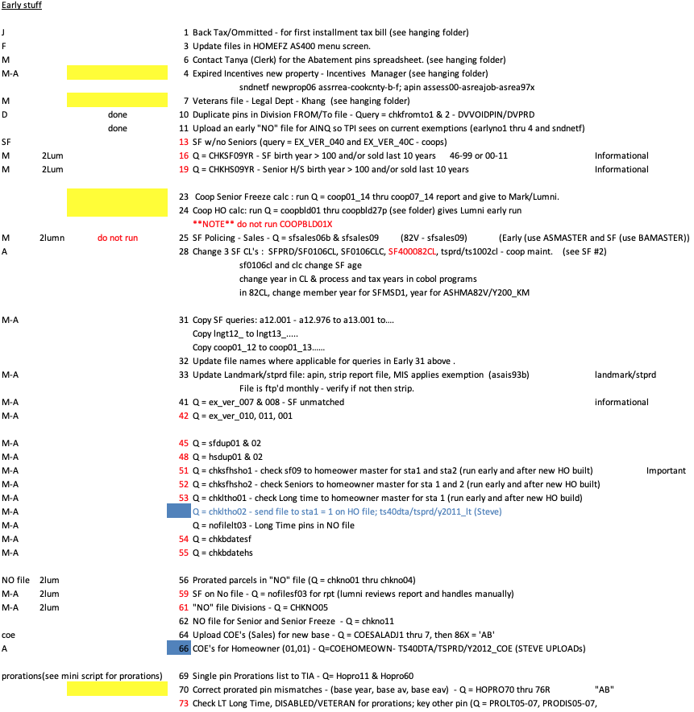

Markdown Syntax and Use Example

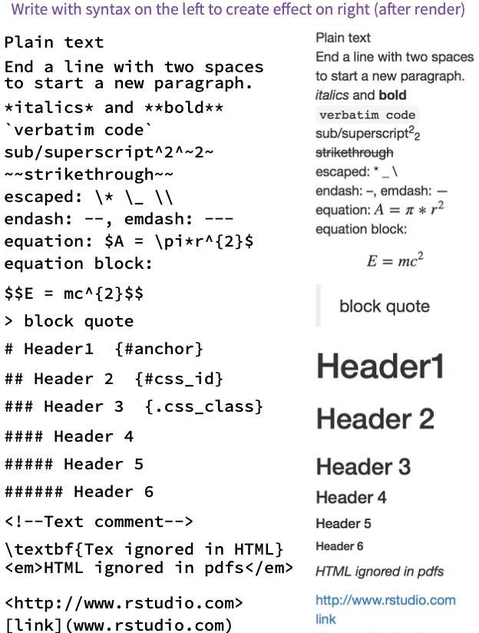

*Pandoc syntax in Markdown*

*Source: RStudio, PBC*

*Syntax input by user shown here…*

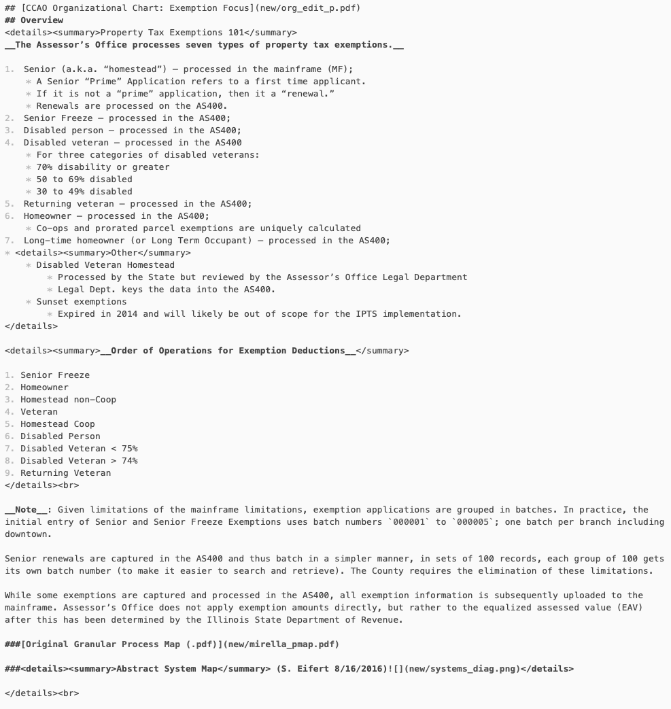

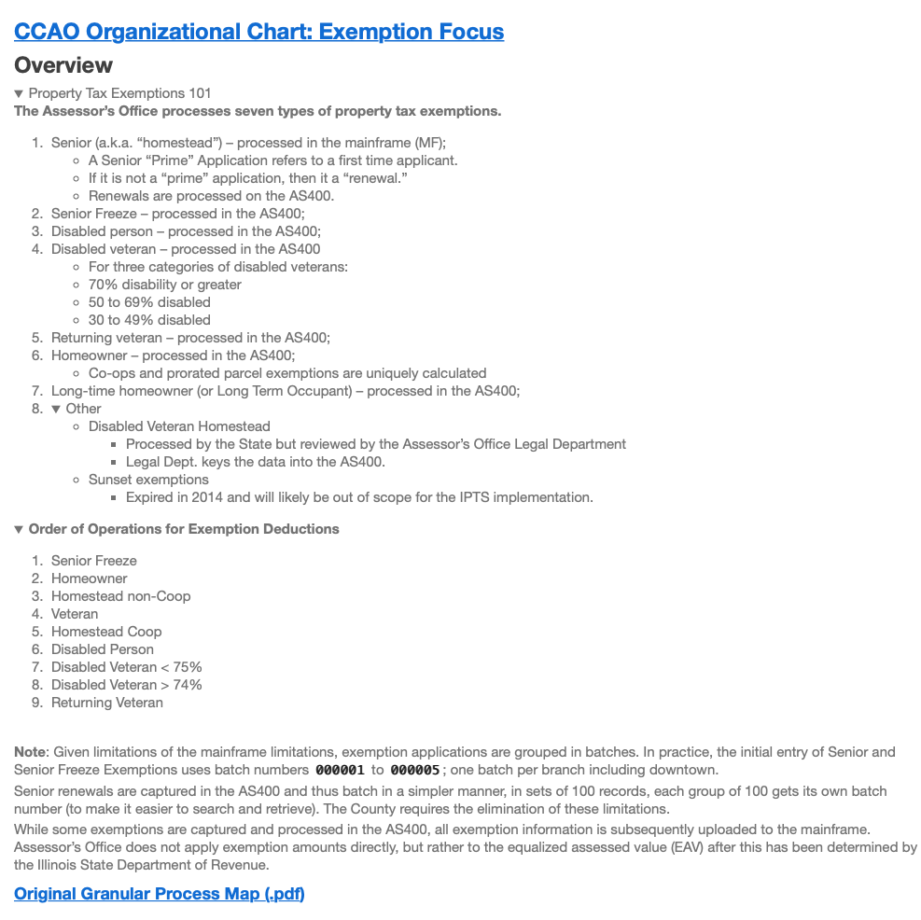

*…generates browser output shown here.*

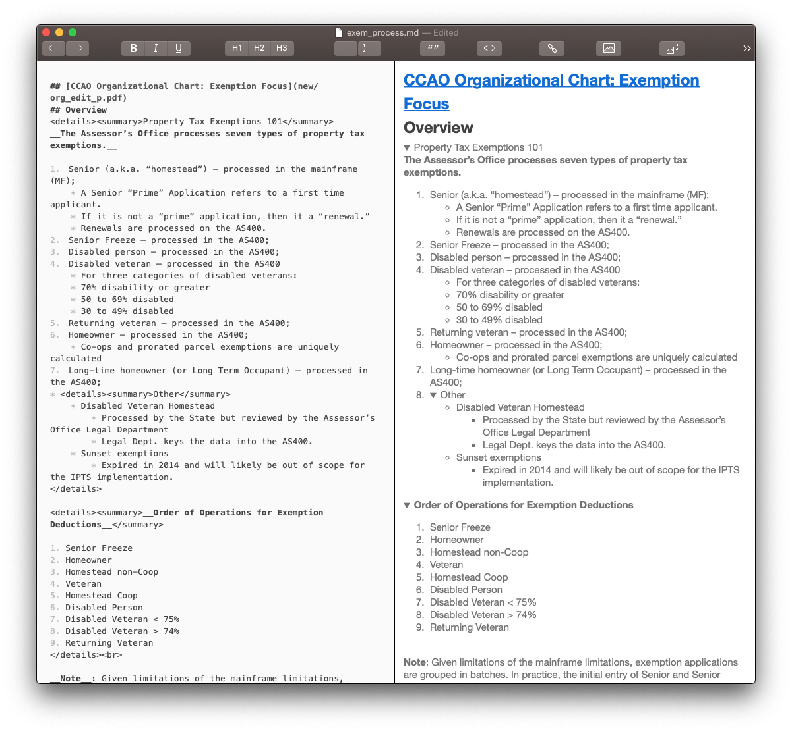

*Macdown interface allows user to see and interact with output in real time.*

1. [About Cook County Government.](https://www.cookcountyil.gov/content/about-cook-county/)
2. Approximate as the change in EAV will affect both the numerater and the denominator of the ratio in the equation; in most non-hypothetical districts, this is a negligible distinction.
3. [The Tax Divide](https://apps.chicagotribune.com/news/watchdog/cook-county-property-tax-divide/methods-commercial.html).
4. [CCAO Gitlab Page](https://gitlab.com/ccao-data-science---modeling).
5. [Now is the Time to Reinvent Legacy Government Processes,](https://patimes.org/time-reinvent-legacy-government-processes/) PA Times.
6. [Practices and Procedures Audit of the CCAO](https://prodassets.cookcountyassessor.com/s3fs-public/reports/PCS_Cook-County_Report_final.pdf), IAAO.
7. The fourth being “valuation methods.”
8. [Practices and Procedures Audit of the CCAO](https://prodassets.cookcountyassessor.com/s3fs-public/reports/PCS_Cook-County_Report_final.pdf), IAAO. (Pg.5).
9. Ibid. (Pg. 6).
10. Ibid. (Pg. 6).
11. [Cook County Assessor Model & Valuation Data Release](https://datacatalog.cookcountyil.gov/stories/s/Cook-County-Assessor-Valuation-Data-Release/p2kt-hk36/), Cook County Government.
12. Ibid.
13. [Residential Property Assessment in Cook County: Assessment Transparency](https://prodassets.cookcountyassessor.com/s3fs-public/reports/2018ResidentialPropertyTransparencyvf.pdf), CCA.
14. [Standard on Public Relations](https://www.iaao.org/media/standards/Standard_on_Public_Relations.pdf), IAAO.
15. [Standard on Mass Appraisal](https://www.iaao.org/media/standards/StandardOnMassAppraisal.pdf), IAAO.
16. [Residential Property Assessment in Cook County: Assessment Transparency](https://prodassets.cookcountyassessor.com/s3fs-public/reports/2018ResidentialPropertyTransparencyvf.pdf), CCA. (Pg. 9).
17. Ibid. (Pg.11)
18. [Mapping public value processes](https://www.emerald.com/insight/content/doi/10.1108/IJPSM-04-2013-0054/full/html), Int. Journal of Public Sector Management.
19. Ibid. (Pg. 336)
20. Ibid. (Pg. 337)
21. Ibid. (Pg. 346)
22. Ibid. (Pg.348)
23. [Process Mapping – The Foundation for Effective Quality Improvement](https://doi.org/10.1016/j.cppeds.2018.08.010), Current Problems in Pediatric and Adolescent Health Care. (Pg. 177).
24. Ibid. (Pg. 179)
25. Mark Kos, CCAO Legal Department, Director of Freedom of Information, interviewed on 2/10/2020
26. <https://draw.io>
27. <https://gitlab.com/ccao-data-science---modeling/residential-exemptions>

    (email RRoss@cookcountyassessor.com for access)